

**FPT ACADEMY INTERNATIONAL**

**FPT – APTECH COMPUTER EDUCATION**

Project:

JADON EVENT MANAGEMNT WEBSITE



Class code:

Curriculum: 6715

Team: Group 2

Hoang Toan Thang (Team Leader) Student1236866

Quach Gia Lam Student1235029

Nguyen Ngoc Thach Student1225467

Instructor:

Le Mong Thuy

December – 2019

**This is to certify that**

**Mr./Ms.:**

Hoang toan Thang

Quach Gia Lam

Nguyen Ngoc Thach

**has successfully designed & developed**

eProject: JADON Website link: https://htt-01.github.io/jadon-191215/

**Submitted by:**

Hoang Toan Thang

**Date of issue:**

06-Jan-2020

**Authorised Signature:**

Contents

1. Acknowledgements 7

2. eProject Synopsis 8

3. eProject Analysis 9

3.1. Problem definition 9

3.2. Requirement Specification: 9

3.2.1. Client: 9

3.2.2. Business/Project Objective 9

3.2.3. Input provided by Client 9

3.2.4. Hardware and software requirement 11

3.2.5. Scope of work 11

3.3. Architecture and Design of the Project 11

3.4. Site Map 12

3.5. Task Sheet 13

3.6. Check list of validations 14

3.7. Submission checklist 15

4. eProject Design 16

4.1. FlowCharts 16

4.2. Mock-up Design 17

5. Screen Shot’s 18

5.1. Home page 18

5.2. Portfolio page 19

5.3. Services 21

5.4. Gallery 22

5.5. Press 24

5.6. Reviews 25

5.7. Team 26

5.8. Contact 27

6. Source Code with Comments 29

7. User Guide 30

7.1. Introduction and website installation 30

7.2. Over view 31

7.3. Fixed Contents 32

7.3.1. Header 32

7.3.2. Footer 34

7.4. Main pages 35

7.4.1. Home 35

7.4.2. Portfolio 37

7.4.3. Services 42

7.4.4. Team 46

7.4.5. Gallery 48

7.4.6. Press 50

7.4.7. Review 51

7.4.8. Contact 52

7.5. Sub pages 54

7.5.1. Turn key premium service 54

7.5.2. Limited service 55

7.5.3. A la carte 56

7.5.4. Service tasks of corporate 58

7.5.5. Service tasks of private 59

7.5.6. Service tasks of school & non-profit 60

7.5.7. Service tasks of wedding 61

7.5.8. Under construction 62

7.5.9. About this website 63

8. Developer’s Guide 64

9. Appendices 65

9.1. Appendix 9-1: Task Sheet 65

9.2. Appendix 9-2: Mock-up of Website layout 67

The End 81

# Acknowledgements

We want to thank Ms. Le Mong Thuy, our teacher and mentor, who has been guiding us through many impossible road blocks of this project. She has been the driver for all teams and was always there to make sure we were keeping up with the progress.

The big part of this project is the imagery which contributes quality graphic to the website. Most of our images were downloaded free of charge from unsplash.com, an excellent image stock with high-resolution. Our website has used photos from many photographers such as Alasdair Elmes, Fred Kloet, Evangeline Shaw and many others who we are keeping record of but can not name all in this report. We like to express our appreciation to these photographers, organizations who make this possible for us.

It worth mentioning here that we have used contents, ideas, code snippets from many websites for our project which we kept track of. Even though the names cannot be all listed here, we also like to give credit to them.

# eProject Synopsis

This eProject is a simulation of real project where the developer team have to design a front-end website for a company called Jadon Event Management.

JADON Event Management Services in the city is famous for catering their services by organizing the complete events like Marriage, Birthdays, Wedding Anniversaries, Promotion parties, Annual Shows at School, Offices and so on. For each type of events there varieties of formats or themes to execute and also charges also keeps on varying based on the type of theme selected. With a view that user has proper idea about the task to performed in event the JADON services wishes to design the website.

The team will apply HTML, CSS, Javascript, Bootstrap as technology to build the website. Detail of the project is in section 3 eProject Analysis.

# eProject Analysis

## Problem definition

The Developer Team is presented with a task to build a website for an event management company. The website is defined as a front-end interaction of JADON with its costumers that will be devised with appropriate tools to link to back-end database in the later stage. The team will have to solve the following problems:

* What is JADON business and what JADON want to communicate to the users.
* Who are the user of the website and what are their priorities in terms of demand for information.
* How to categorize and group information into pages to tell an interesting story about JADON services, experience, capabilities. At the same time the user can immediately see what service they are looking for
* How to gather all information from JADON and acquire additional material to follow the defined narrative.
* As the front-end interaction, how to provide users with smoothest access in the fastest and most attractive manner. What is the fastest ways to contact or make reservation with JADON.
* The website have to have the richest of information without redundancy.

The website is to be developed for the Windows Platform using HTML5, JavaScript and Geolocation. The site should work well in all leading browsers including Chrome, IE, Firefox etc.

## Requirement Specification:

### Client:

JADON Event Management Services

### Business/Project Objective

JADON Event Management Services in the city is famous for catering their services by organizing the complete events like Marriage, Birthdays, Wedding Anniversaries, Promotion parties, Annual Shows at School, Offices and so on. For each type of events there varieties of formats or themes to execute and also charges also keeps on varying based on the type of theme selected. With a view that user has proper idea about the task to performed in event the JADON services wishes to design the website.

### Input provided by Client

#### Input to the system

List of business categories and detail description

Interview with managers and staff to capture the business spirit and its inspiration

Documents and graphic materials to depict the business and its categories

Additional copy writings and graphics procured by the client requested by Developer Team.

#### Output from the system

Website with categorize services, experience, resource, delivery, contact for the user to understand and to use services of JADON including:

* The Home page should be designed stating some information about the event services and proper template must be designed.
* Uniformity and Navigation must be made smooth throughout the website.
* Different themes for each category along with the list of the task which they perform must be stated.
* Some reviews and past events details.
* Press reviews.
* Gallery section must be included.
* Our team Members.
* About us
* The “Contact Us” page should have the Address of the Company and the mail address which when clicked will invoke the local mail client from where they can send an email. Address of the Company should be displayed using GeoLocation API (eg. GoogleMaps).
* Feedback must be allowed to enter by the viewer
* Site map, Gallery, about us, Queries link, Contact us link must be added.

#### Process involved in the system

Each page will represent a category of JADON’s business at different level. All the text, images, graphics must be programmed to load, position and present as intended by the Designer and following approved story line.

User can follow the links to other pages to continue the story line. These links are structured so that user can get to any information within couple of click.

Information or queries from user/customer to JADON can be implemented by a click from any page to a query form or email. Access to JADON’s social media account also be done by the same way.

#### Expected delivery date

All deliverable is to be submitted by 7/1/2020.

#### List of deliverables

Project documentation

User guide

Complete Source code and supporting Files and Folders.

### Hardware and software requirement

#### Hardware requirement

A minimum computer system that will help you access all the tools in the courses is a Pentium 166 or better

64 Megabytes of RAM or better

#### Software requirement

Notepad/HTML editor

Dreamweaver

IE 5.0/ Netscape 6.0

The website is to be developed for the Windows Platform using HTML5, JavaScript and Geolocation. The site should work well in all leading browsers including Chrome, IE, Firefox etc.

### Scope of work

JADON Event Management Services in the city is famous for catering their services by organizing the complete events like Marriage, Birthdays, Wedding Anniversaries, Promotion parties, Annual Shows at School, Offices and so on.

The scope of work for the Developer Team is to design a website which is defined as a front-end interaction of JADON with its customers. The website provides everything customers need to know about JADON such as services, experience, resource, delivery, contact. It acts as the gateway to promote JADON and attract new business through online reservation and exchange information.

## Architecture and Design of the Project

This website at this stage is a simple front-end website. The architecture of the project is simply a series of html files, supported by .css and .js, that are linked together to give user basic information about Jadon Event Management. Currently at this stage there is no back-end database behind this website.

The website follows the structure of service providing business website which divide information in the following categories: portfolio, services, gallery, team/contact, press/review.

## Site Map

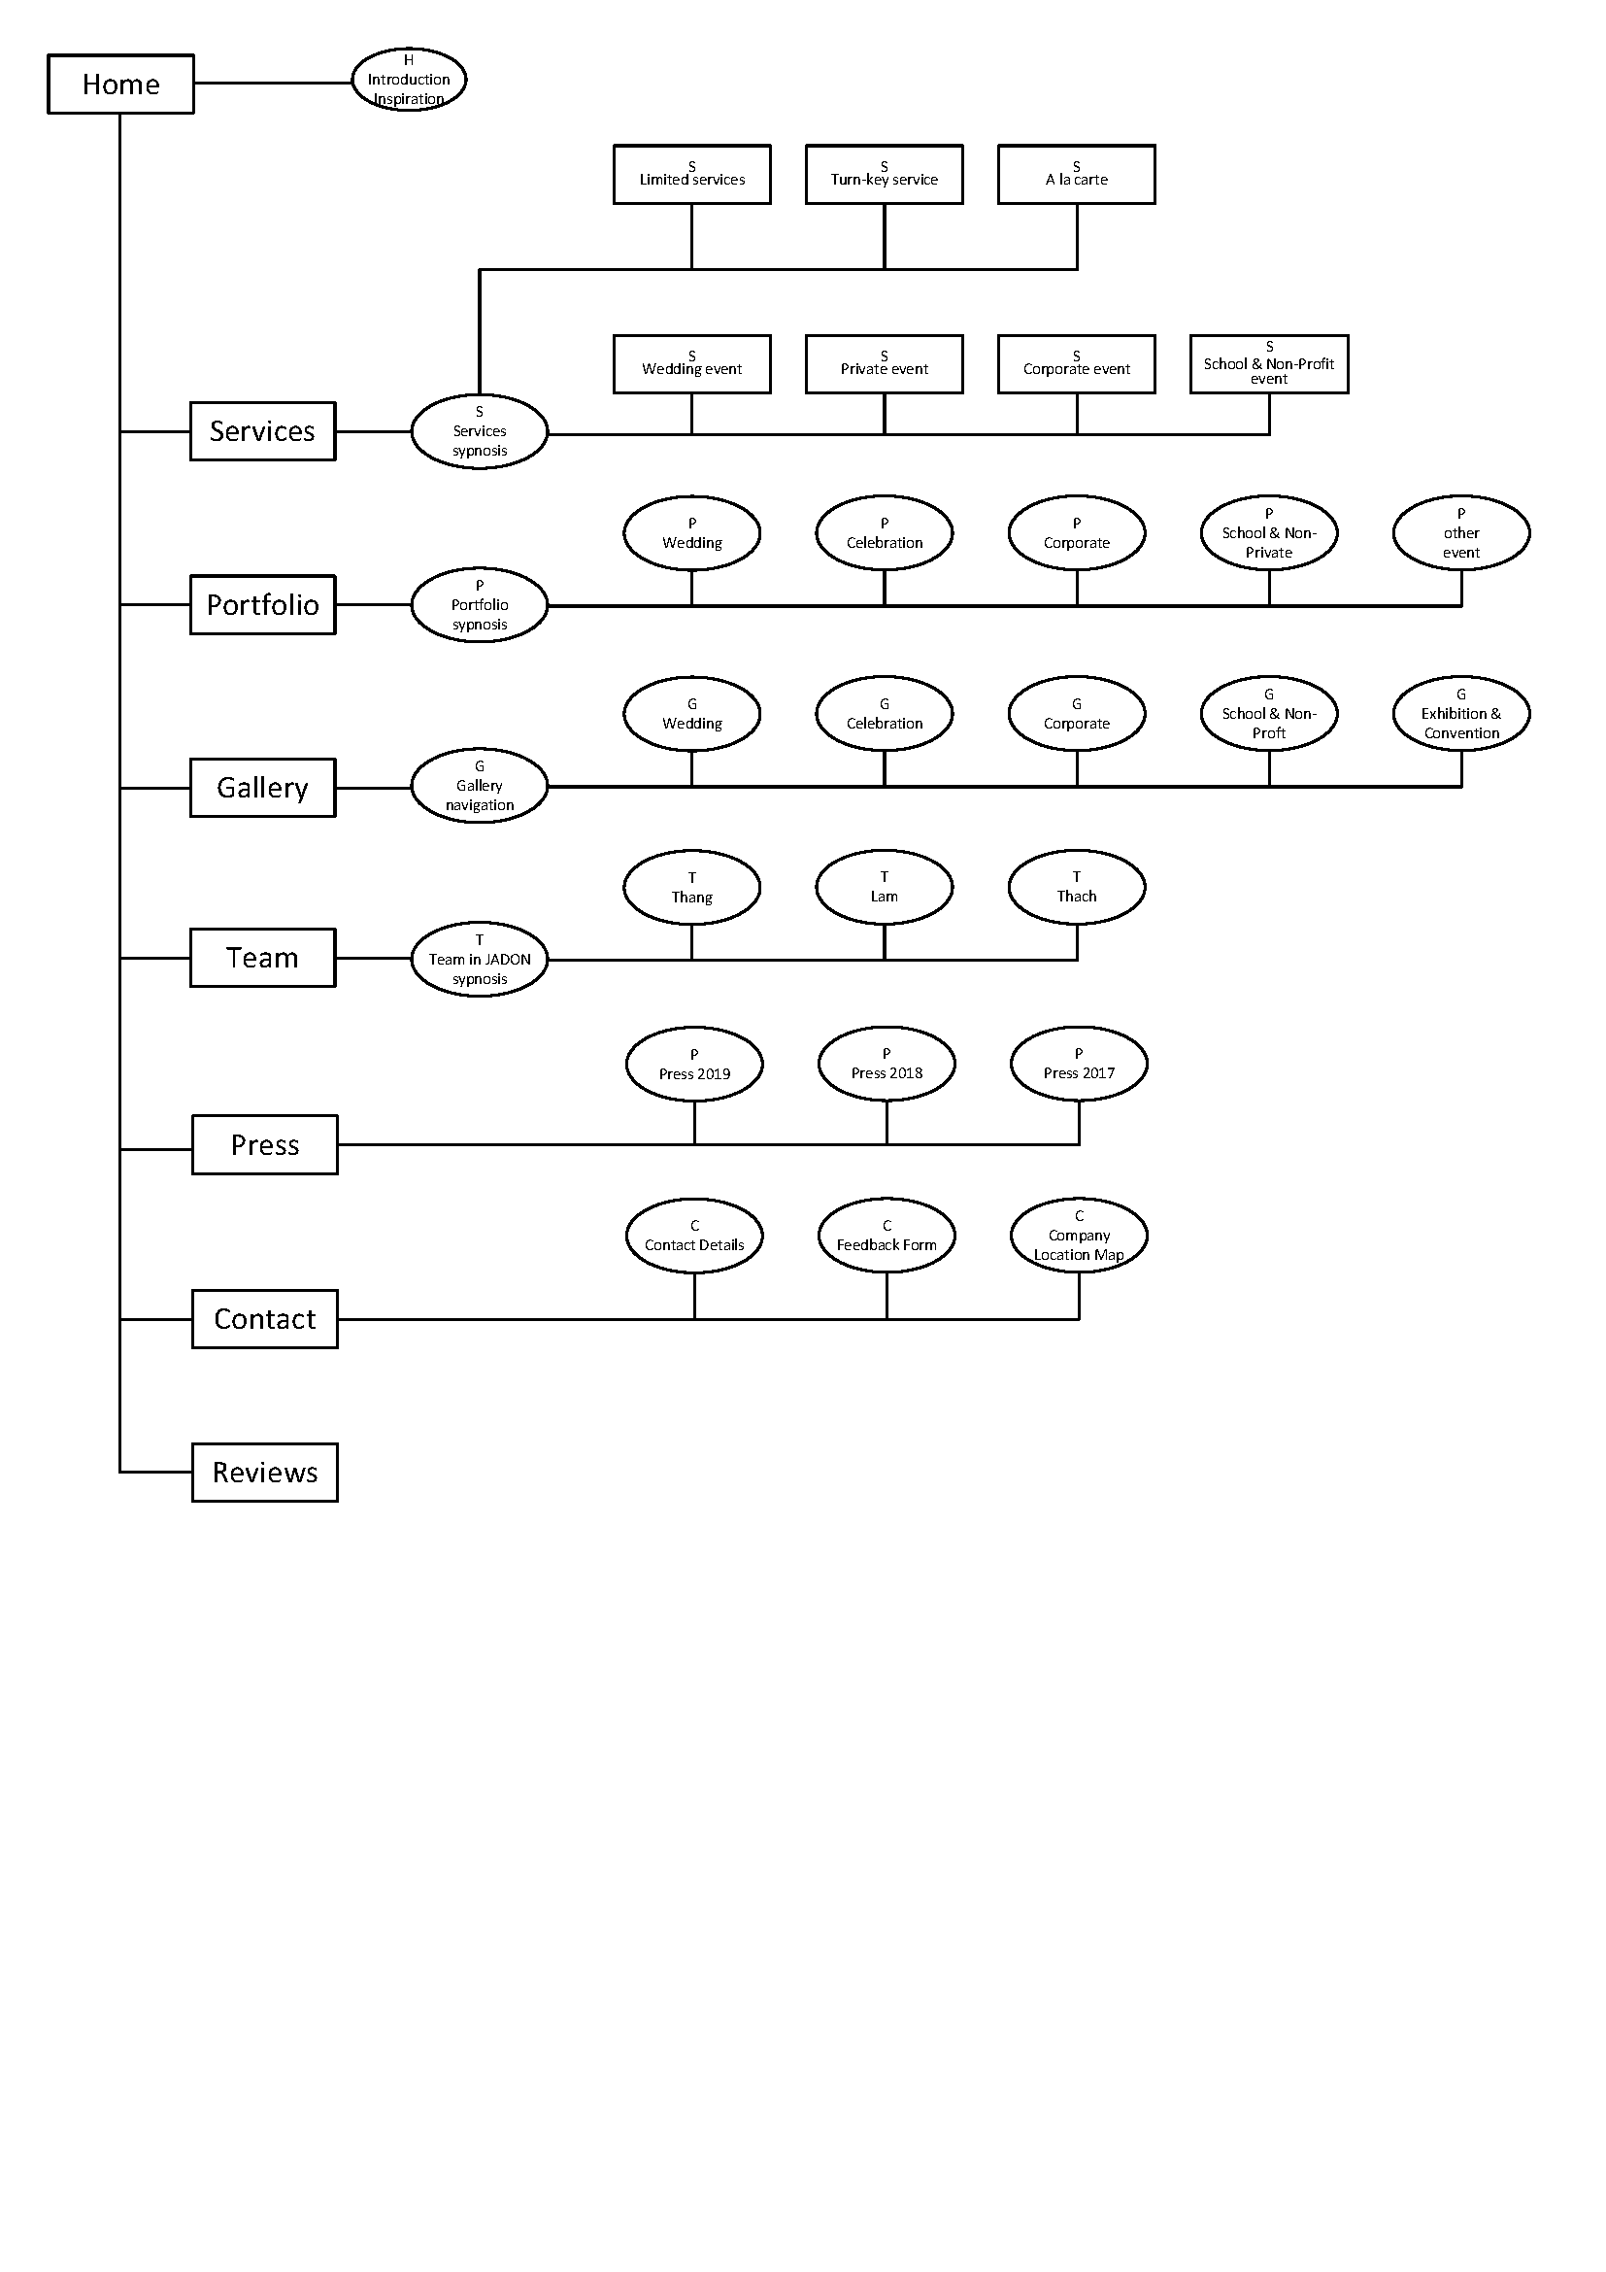

## Task Sheet

Refer to 9.1 Appendix 9-1: Task Sheet

## Check list of validations

|  |  |
| --- | --- |
| **Option** | **Validated** |
| Do all numeric variables have a default value of zero? | NA |
| Does the administrator have all the rights to create and delete the records? | NA |
| Are all the records properly fed into the appropriate database? | NA |
| Have all the modules been properly integrated and are completely functional? | NA |
| Have all the Design and Coding Standards been followed and impletemented? | Yes |
| Is the GUI design consistent all over? | Yes |
| Is the navigation sequence correct through all the forms/screens in the application? | Yes |
| Is exception handling mechanism implemented in all the screens? | Yes |
| Are all the program codes working? | Yes |

## Submission checklist

|  |  |  |  |  |  |
| --- | --- | --- | --- | --- | --- |
| Sr. No. | Particulars | Yes | No | NA | Comments |
| 1 | Are all the users able to search for a particular record? |  |  | x |  |
| 2 | Are all the old records properly saved and retrieved when required? |  |  | x |  |
| 3 | Have all the modules been properly integrated and are completely functional? |  |  | x |  |
| 4 | Are the GUI content devoid of spelling mistakes? | X |  |  |  |
| 5 | Is the application user-friendly? | X |  |  |  |
| 6 | Is the project published properly into a setup file? | x |  |  |  |

# eProject Design

## FlowCharts

As the architecture of this project is a series of html files that are inter-linked, viewer can get to any information just within 2 clicks by using navigation menu in header/footer or by using the dropdown menu site map in the header. Refer to *7.3.1 Header* and *7.3.2 Footer* for more information.

## Mock-up Design

Refer to 9.2 Appendix 9-2: Mock-up of Website layout

# Screen Shot’s

## Home page

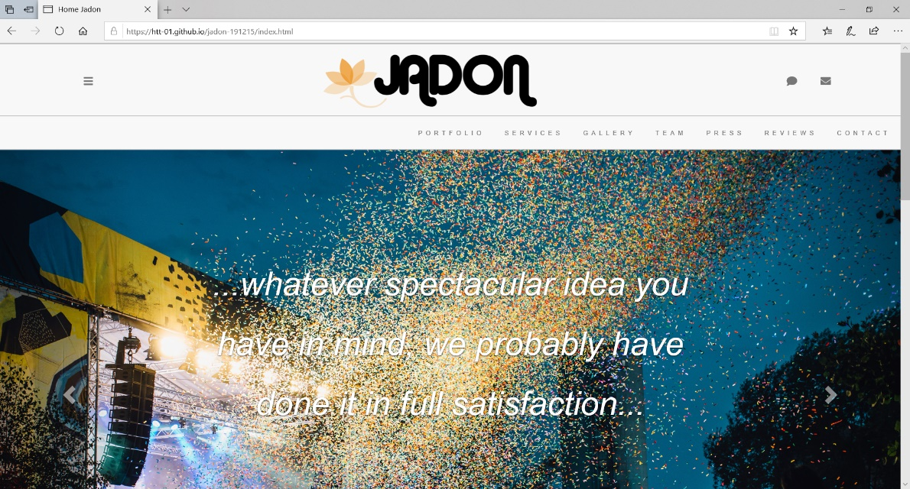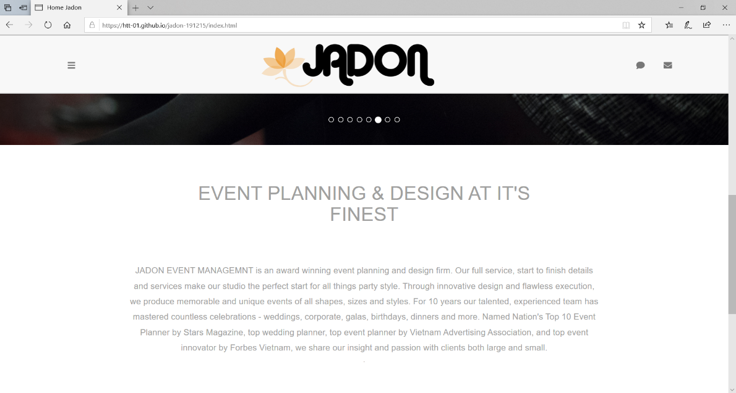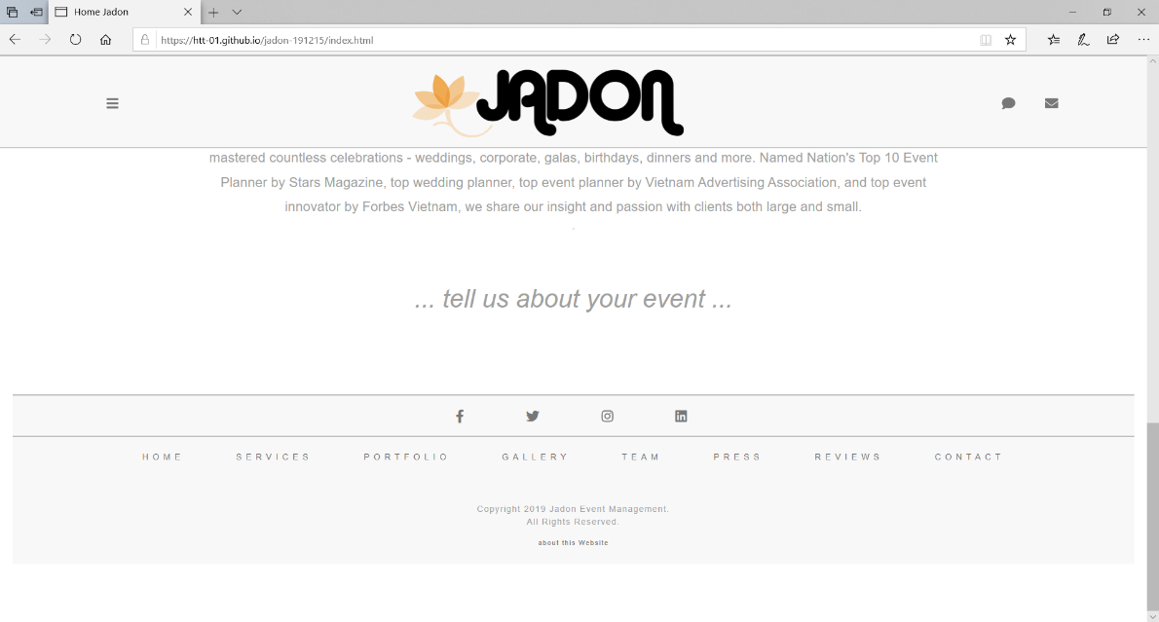

## Portfolio page

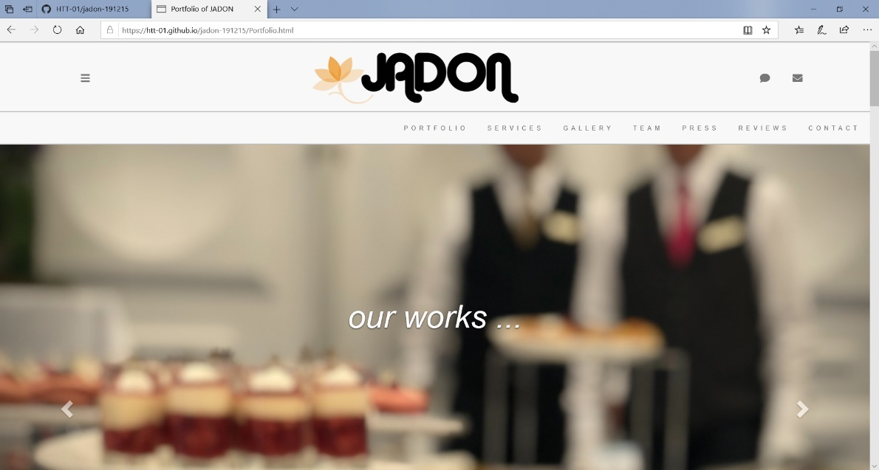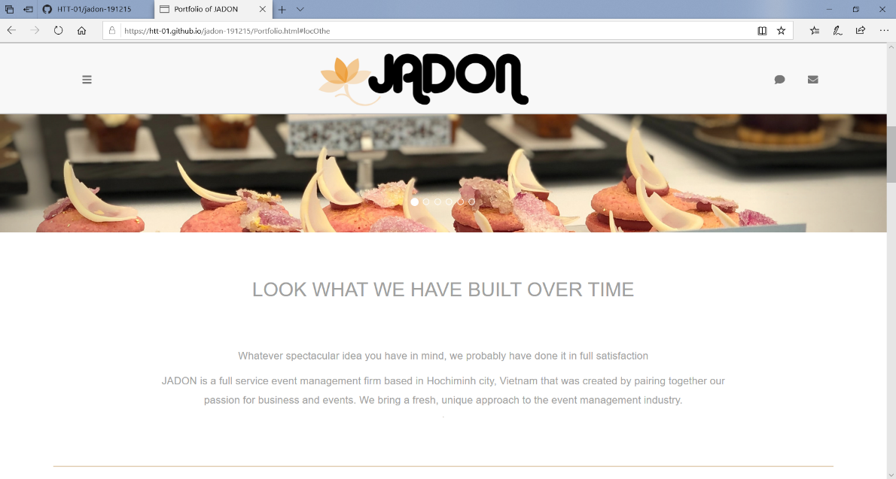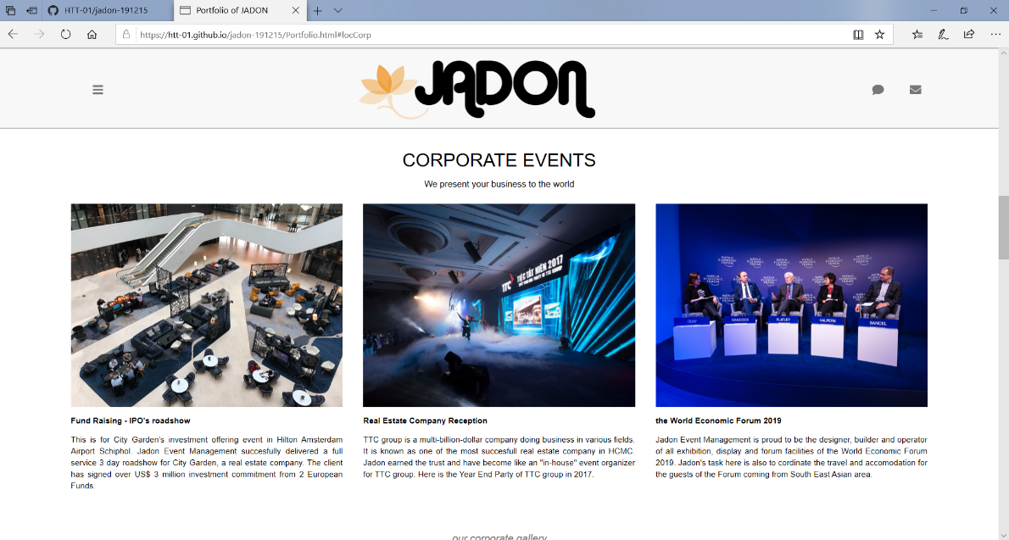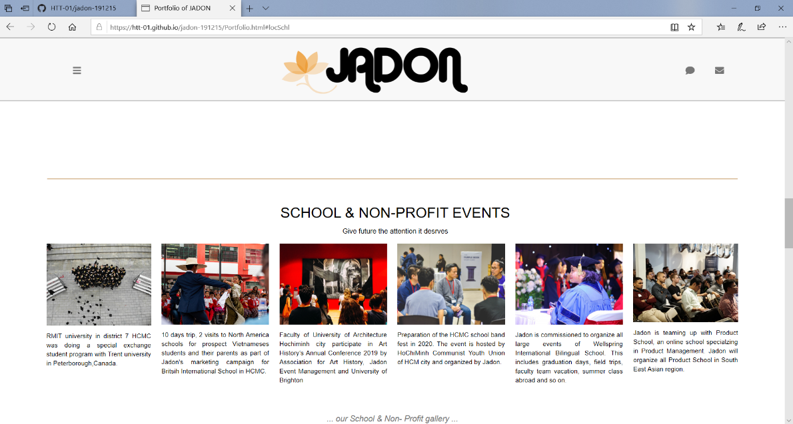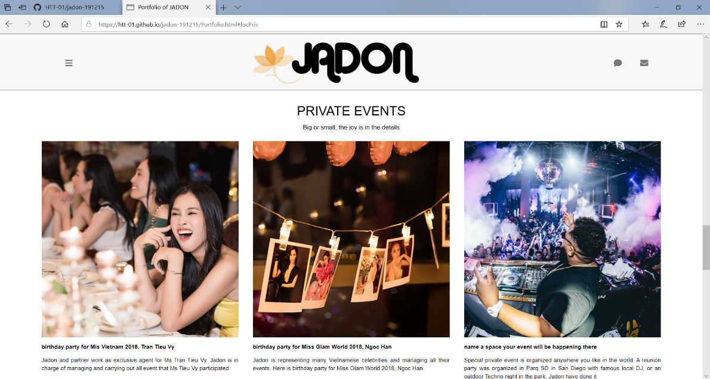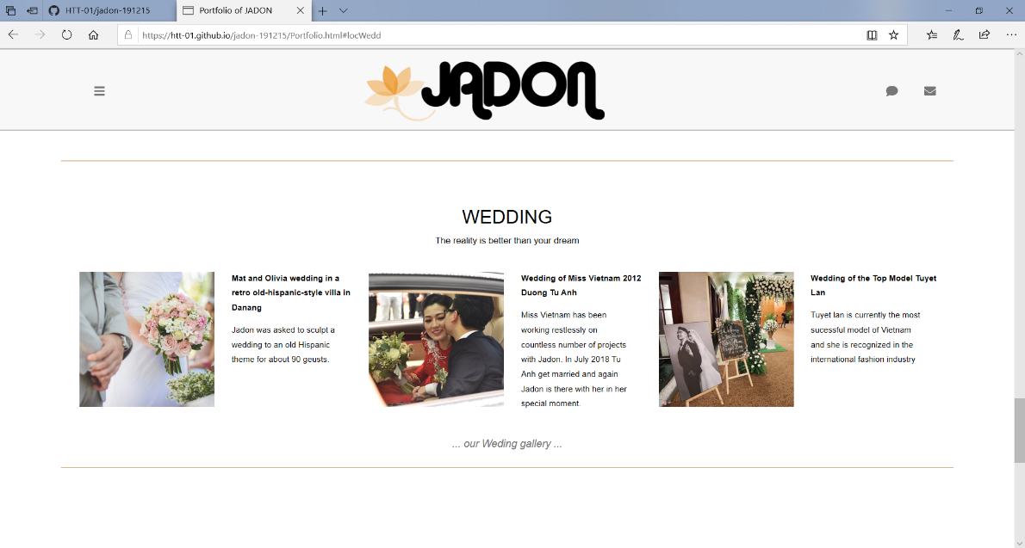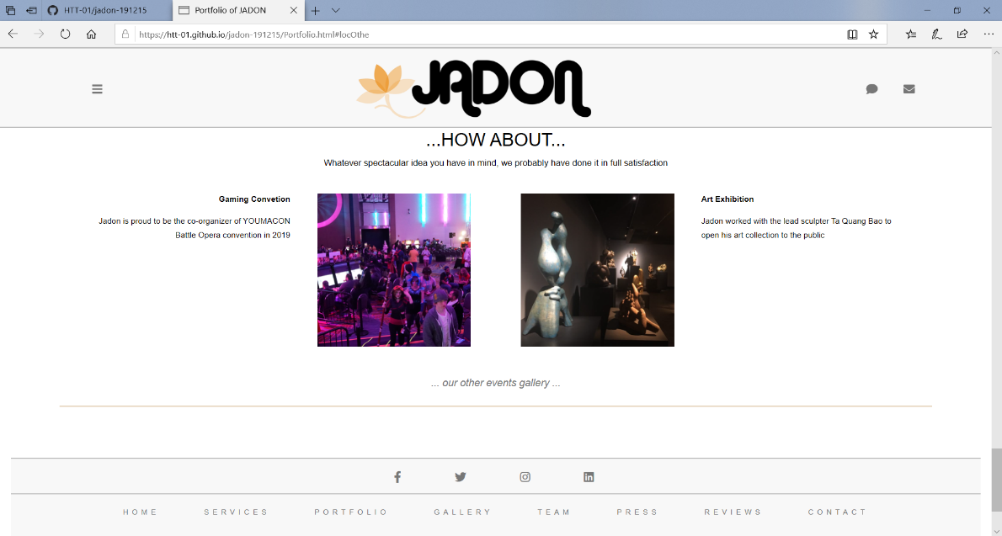

## Services

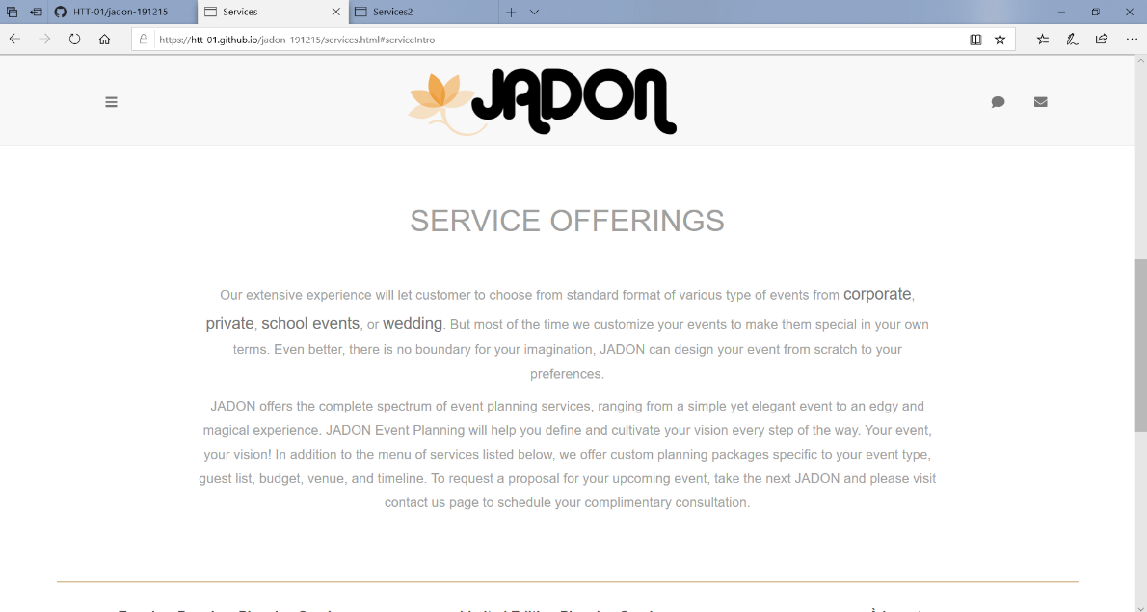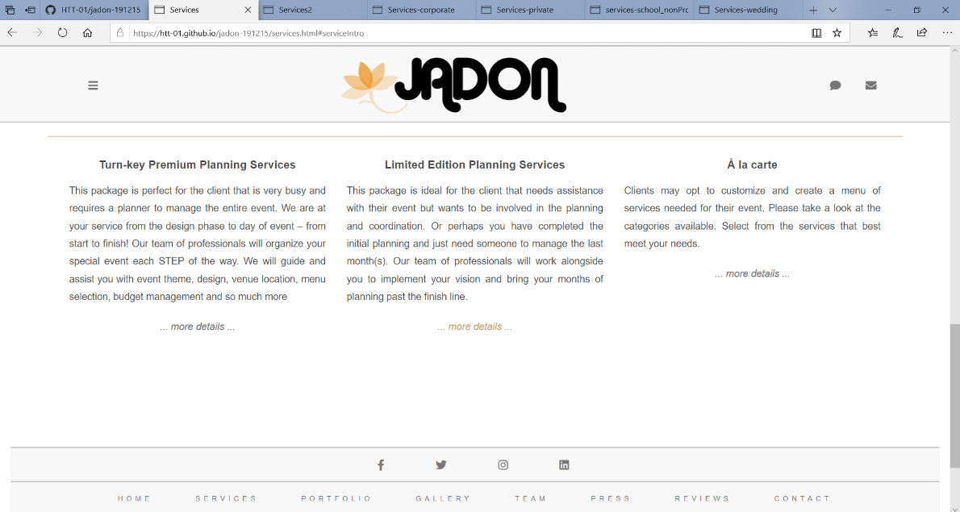

## Gallery

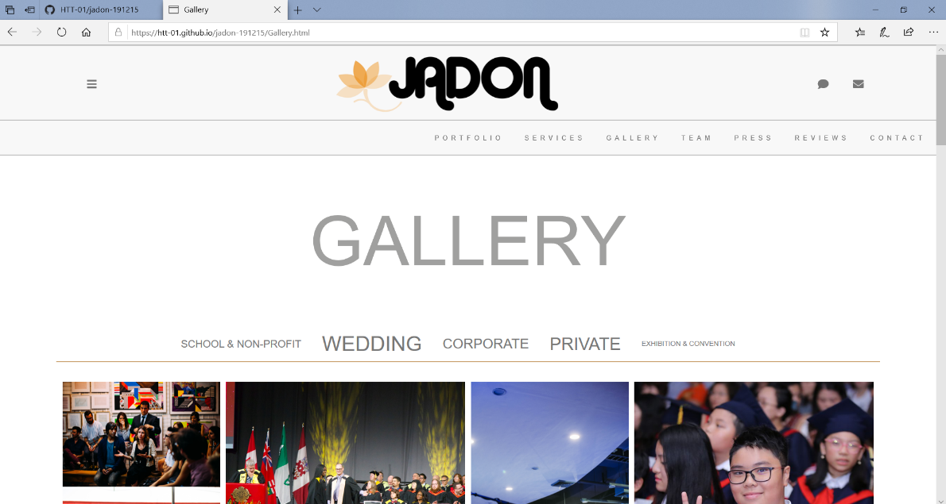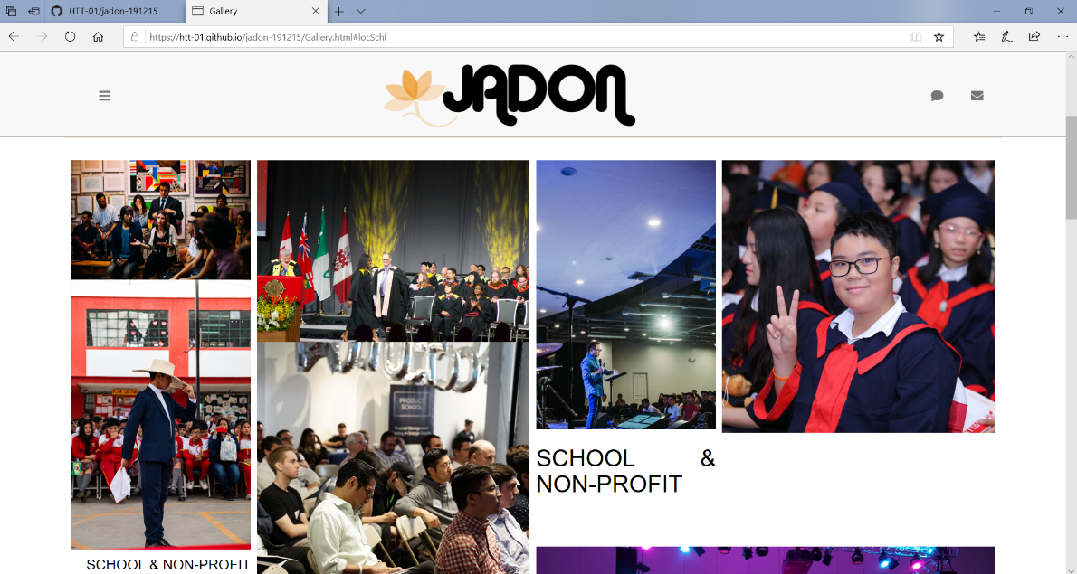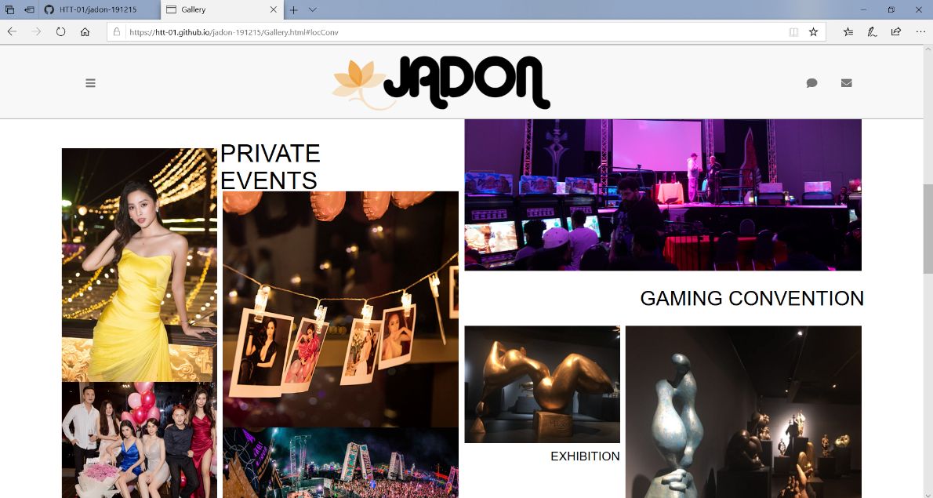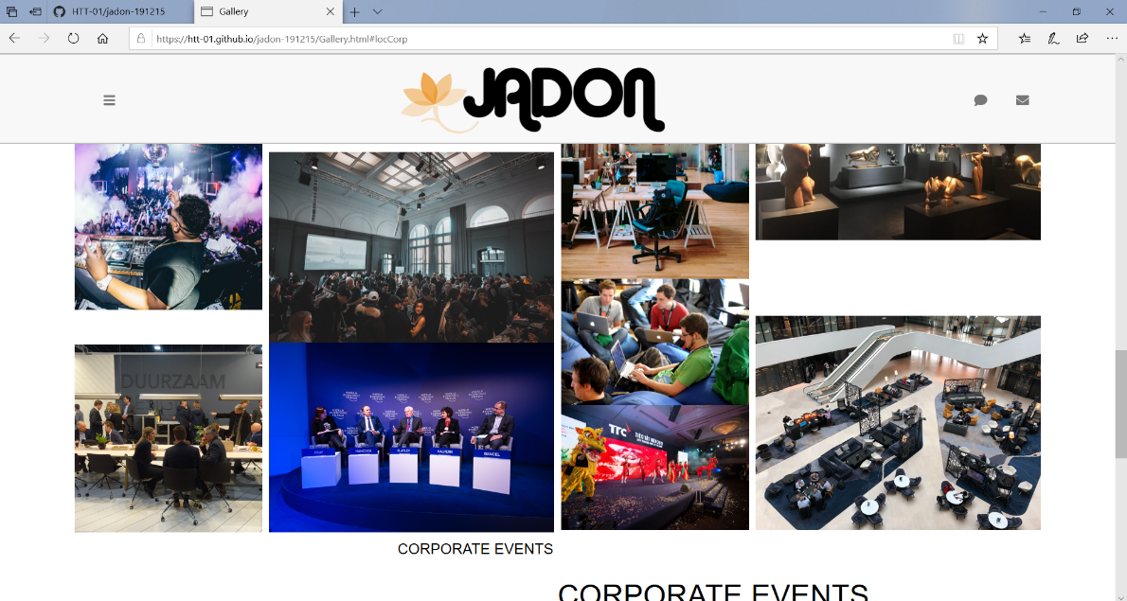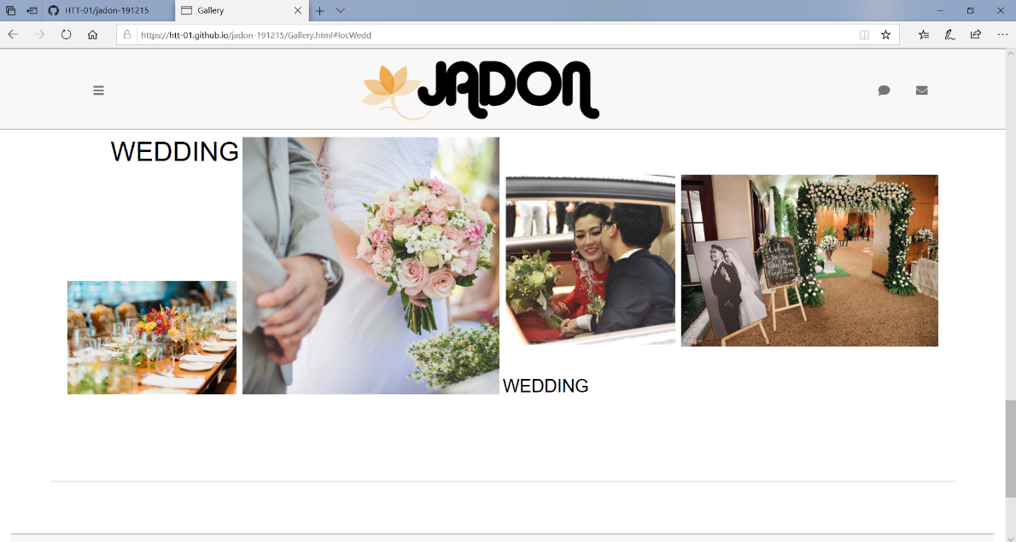

## Press

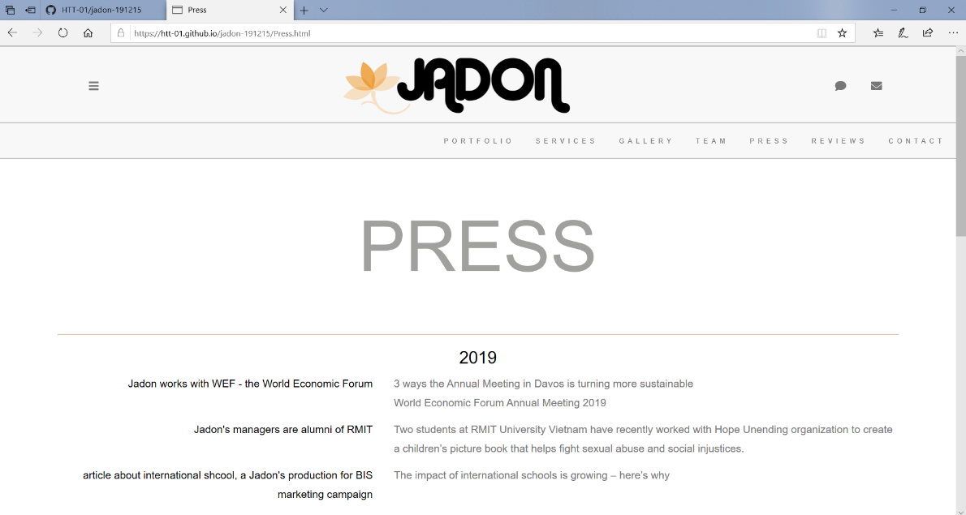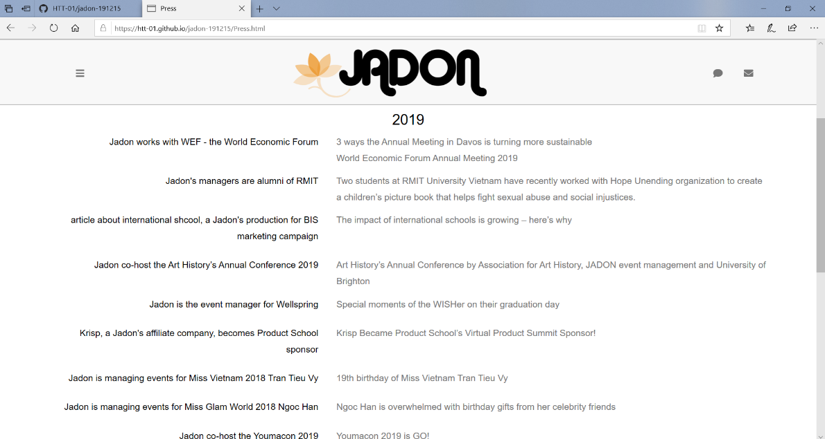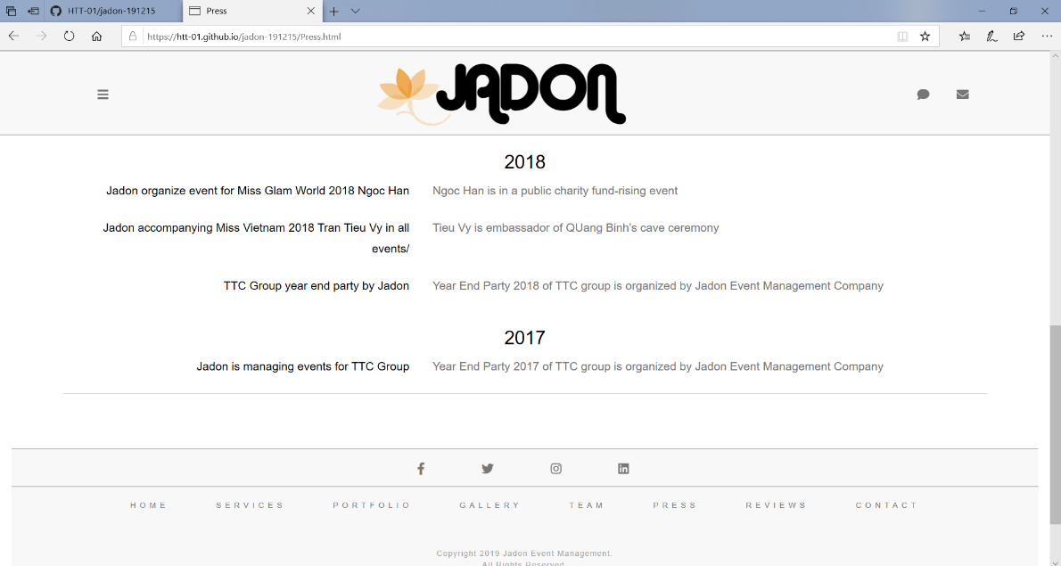

## Reviews

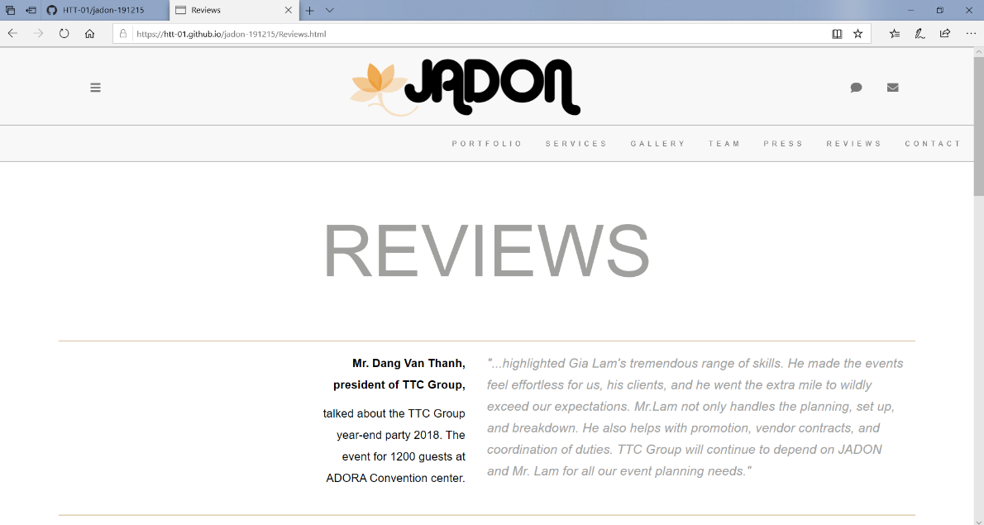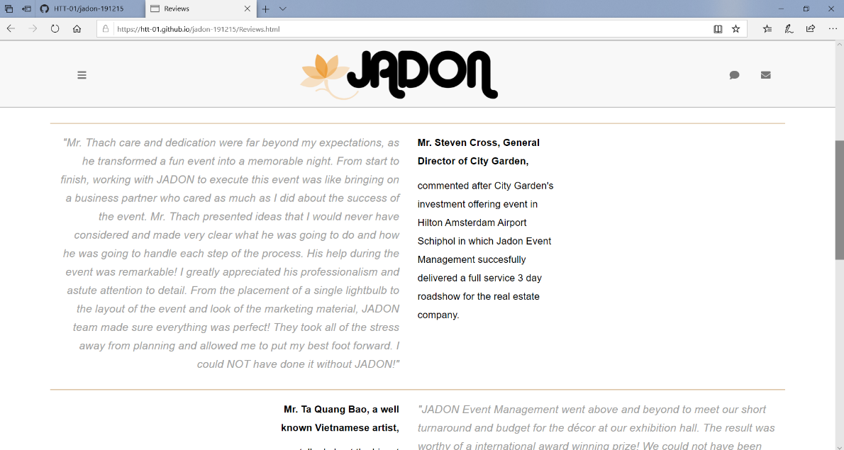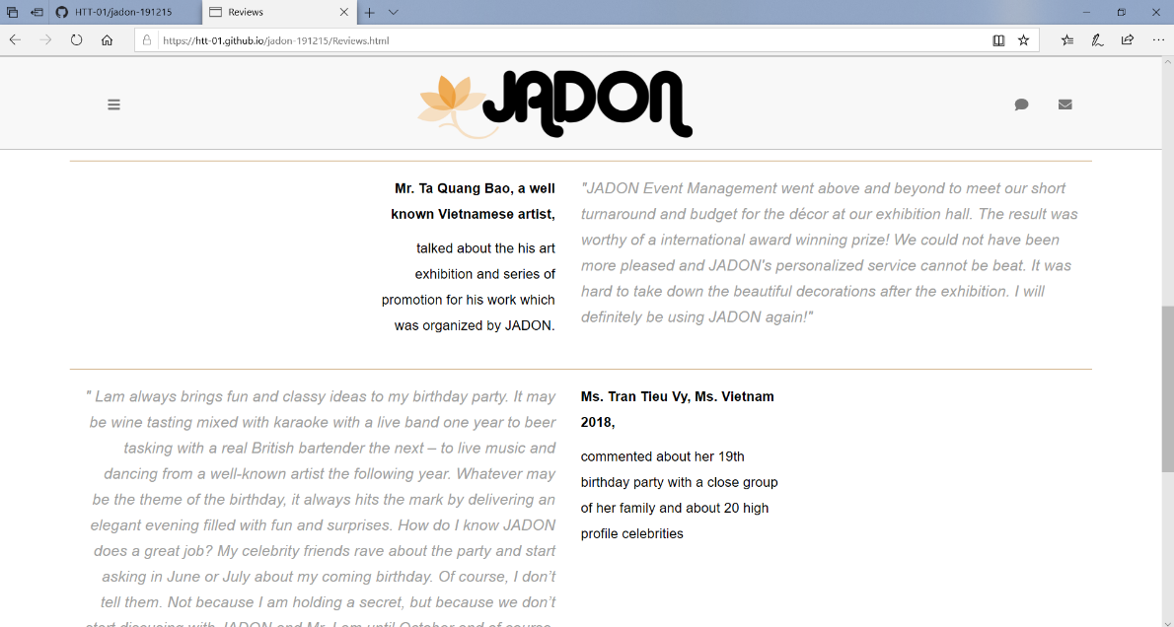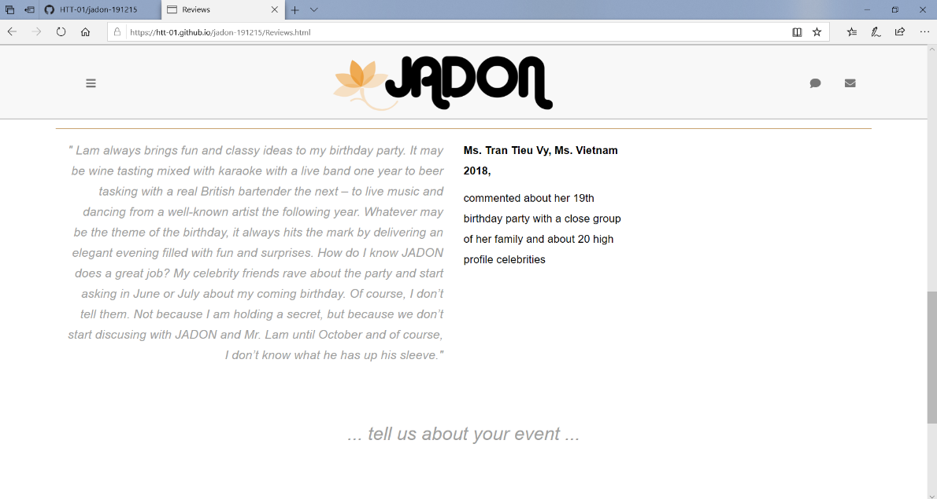

## Team

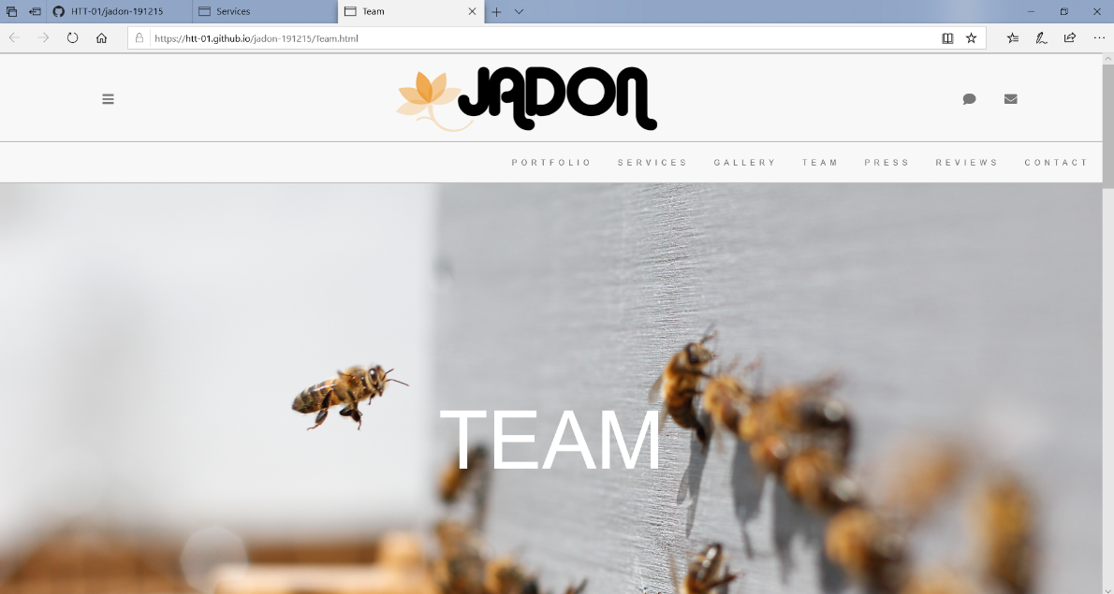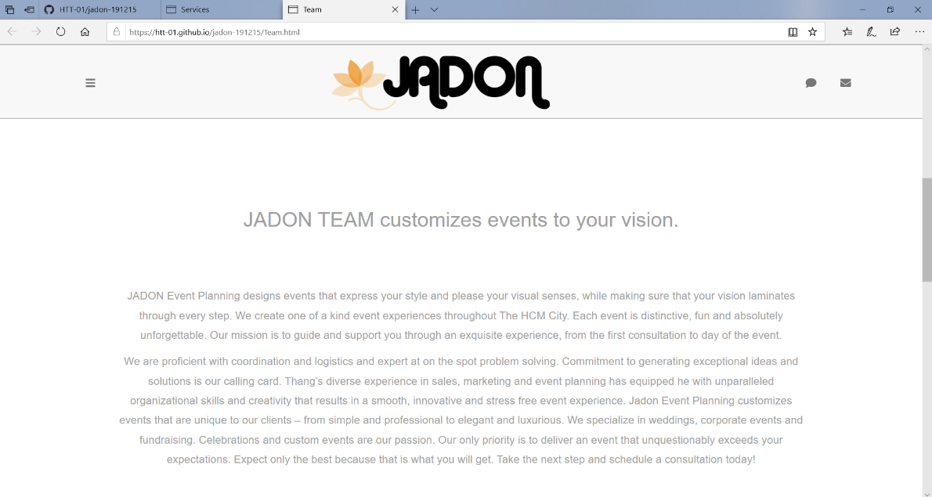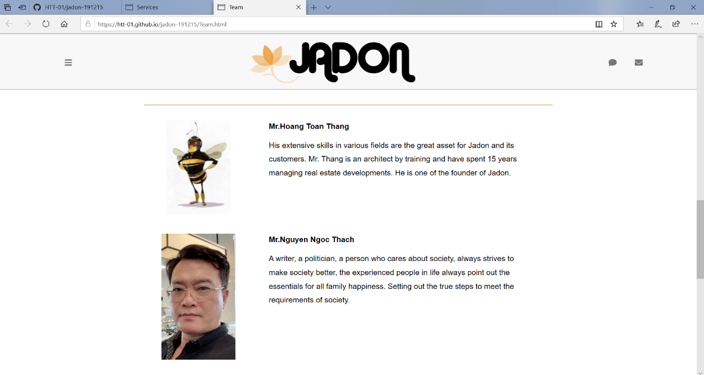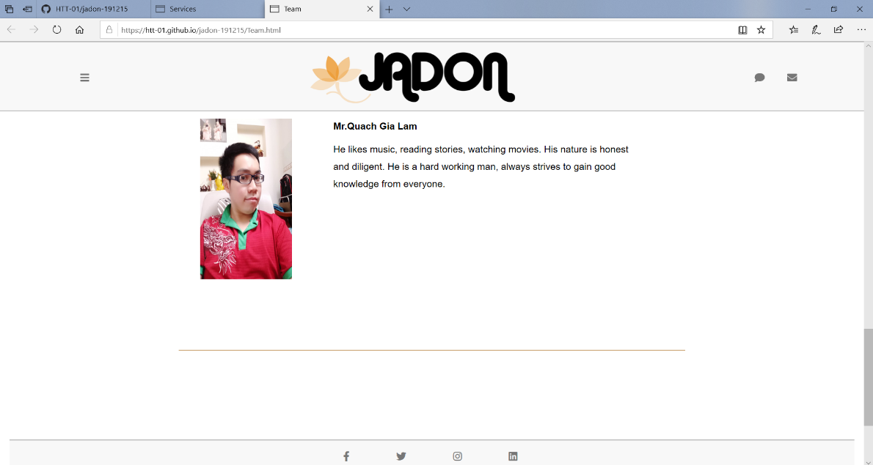

## Contact

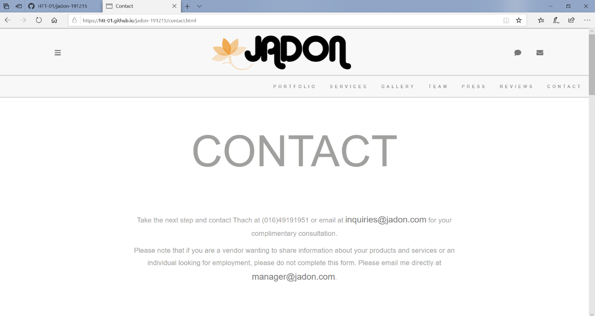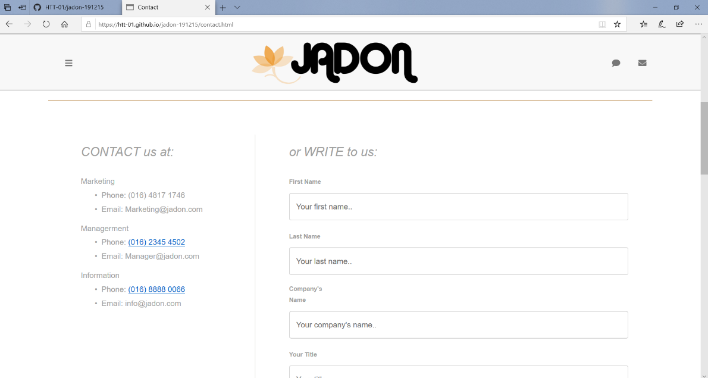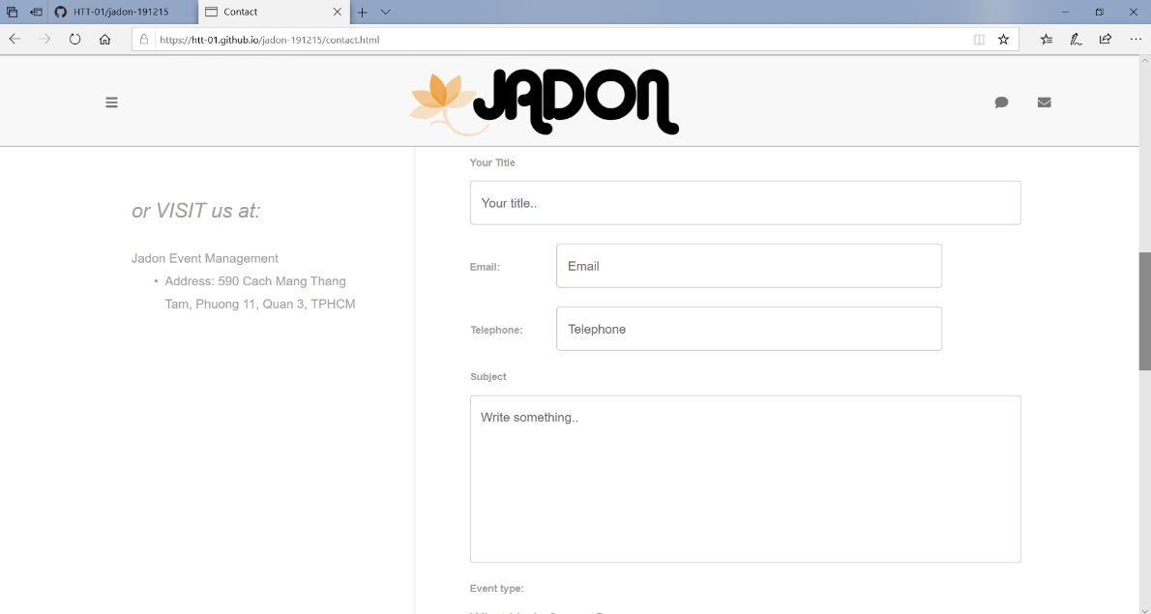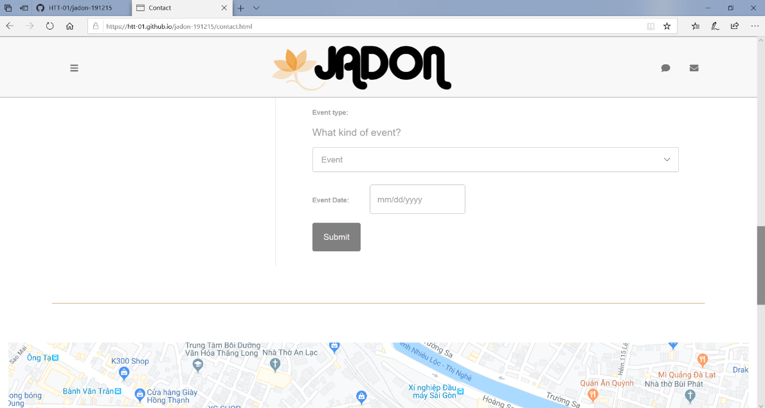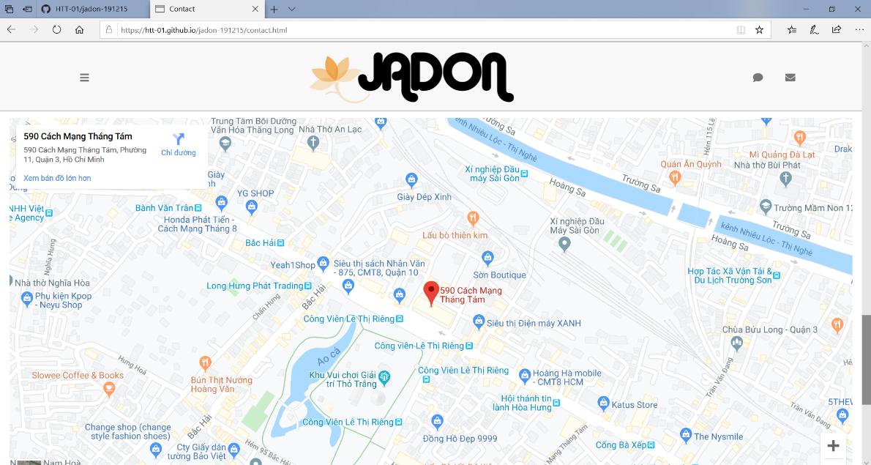

# Source Code with Comments

This is the very first go with designing the website for Jadon. There are a lot of twists and turns in html and css files to come up with a graphic and branding design that satisfies the company’s requirement. Therefor there are many “inline style” in the source code that are not standardized into css style sheet. 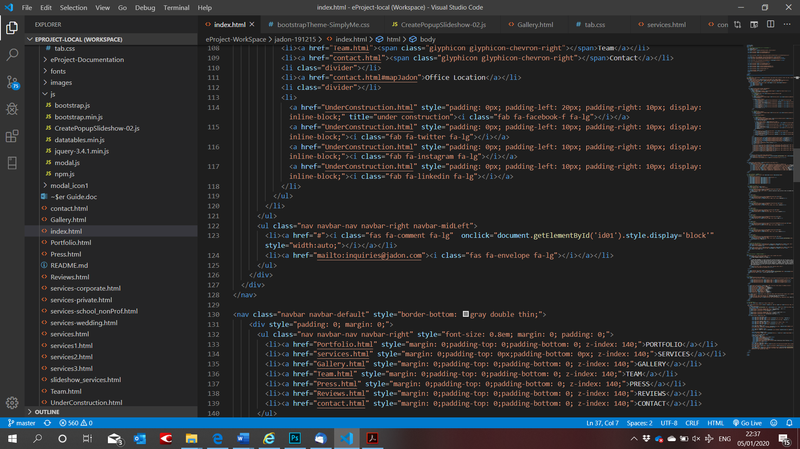

The next step to work with Jadon is to pull out all these “inline style” into css files as a branding design for Jadon which can apply easily onto extension of the website in later stages.

# User Guide

## Website installation

To install *Jadon* website, users need to do the following steps:

1. Download the file rar*eProject – Jadon by Group 2 (FPT Aptech HCM)*via_this_link: <https://drive.google.com/file/d/16QMxdl0uk1DZm0oZZm_se7MVGopR1fQi/view>
2. Extract the file rar: *eProject – Jadon by Group 2 (FPT Aptech HCM)*
3. Open the folder *jadon-191215*
4. 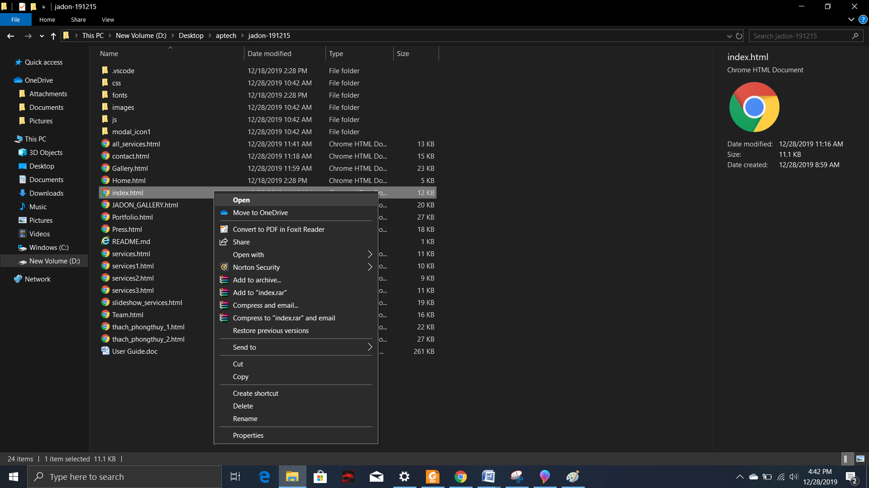Open *Index.html* file to start the website as below illustration

## Over view

There total 15 pages includes 8 main pages and 7 sub-pages in the website to tell everything about Jadon Event Management. All of which is to answer the following questions:

1. Who is Jadon?
2. What does(/can) Jadon do for me?
3. What kinds of work has Jadon done?
4. What is the quality of Jadon’s works?
5. How can I talk to Jadon now?

Below is the how the content of pages was designed around these questions

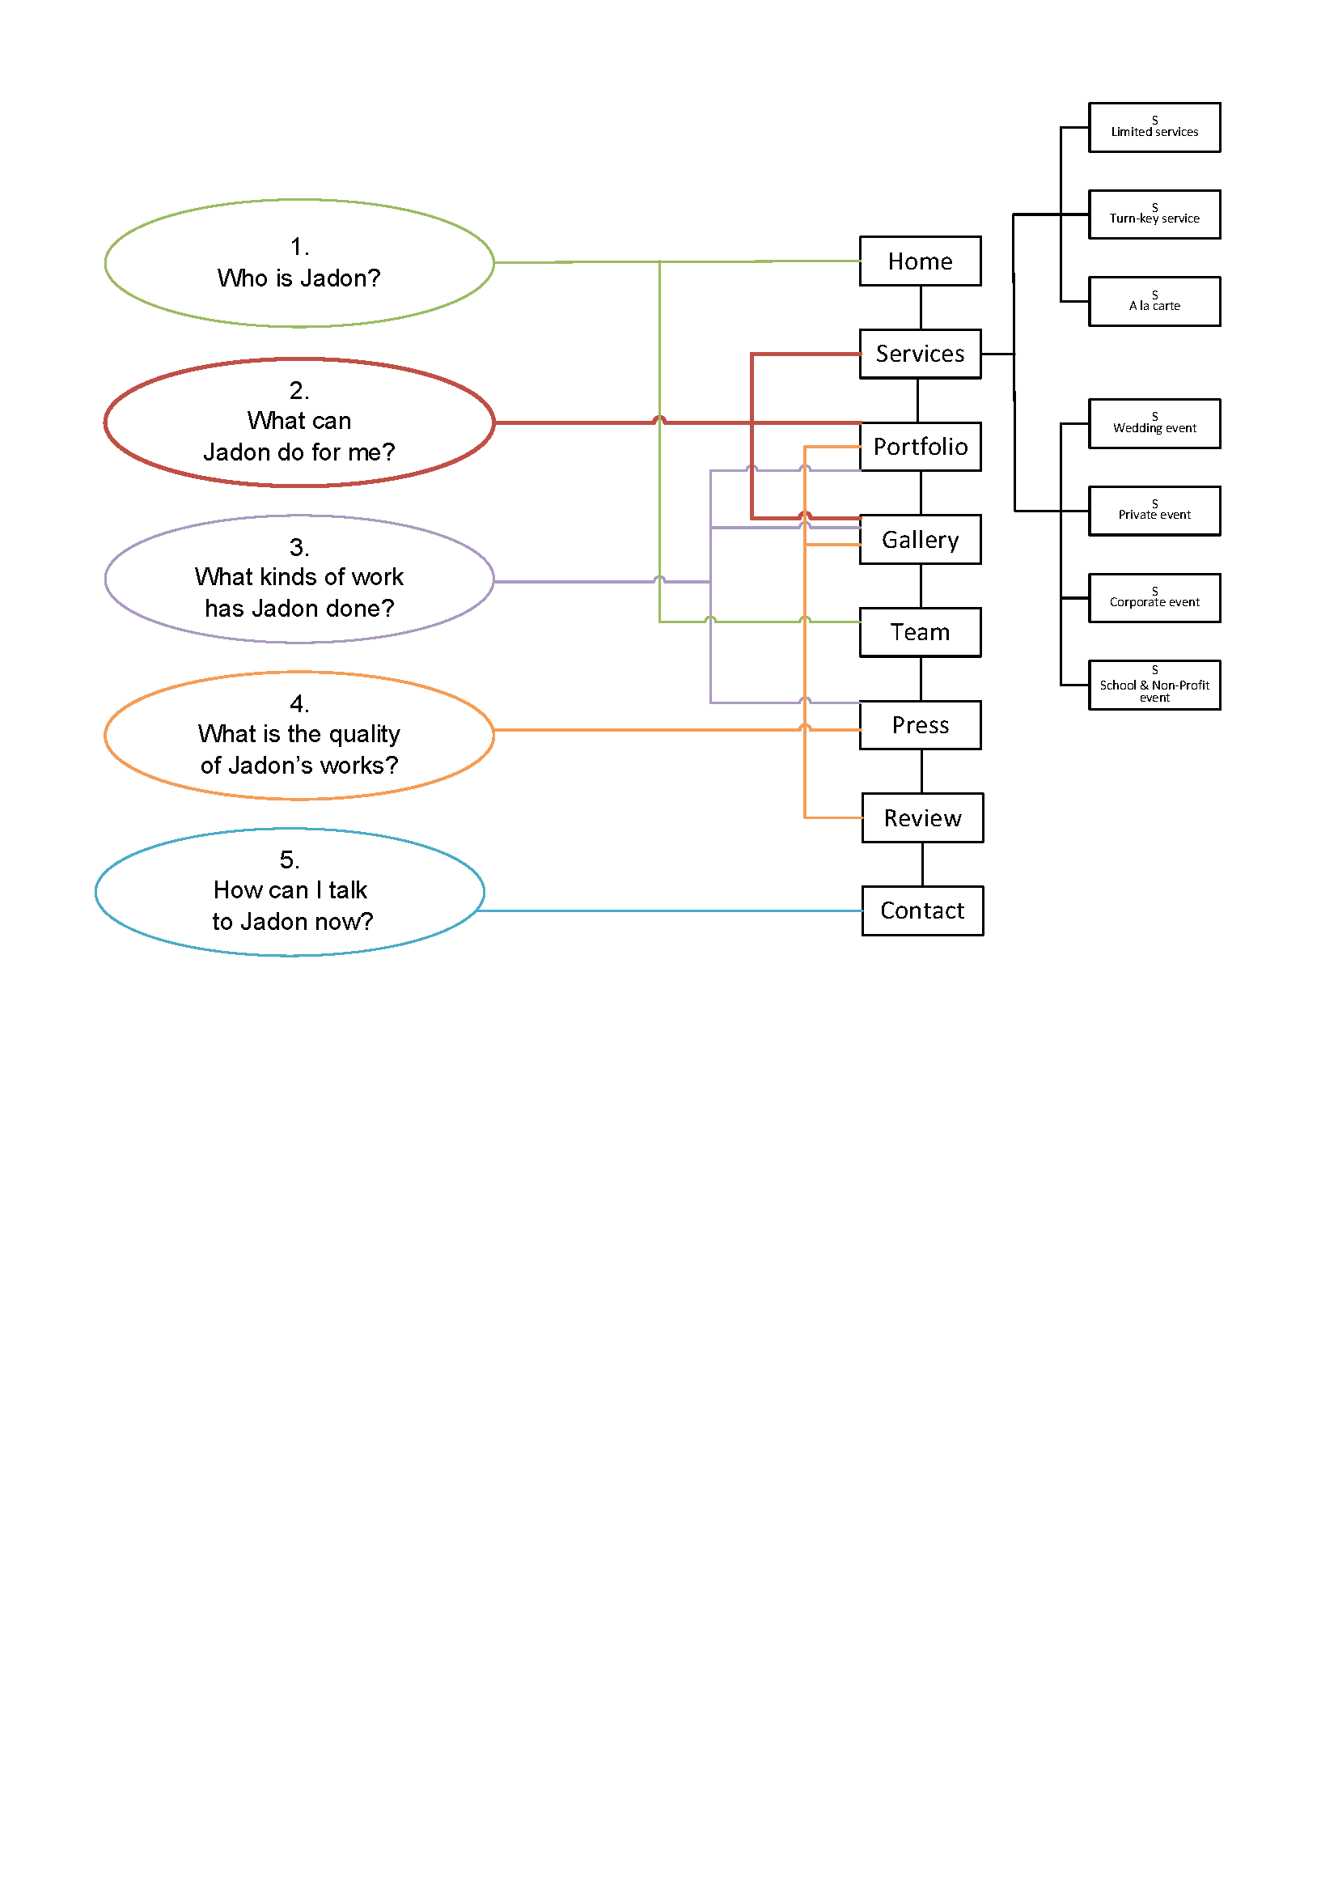

## Fixed Contents

Fixed contents are information that is displayed on every page. This information is so important to Jadon that it virtually is in front of the viewer all the time to access. They are in **header** and **footer** of the web pages.

### Header

Header is on top of every page. It contains Site Map Icon, Top Website Navigation Menu, Jadon Logo, Link to Message Form, Link to Email-to-Jadon action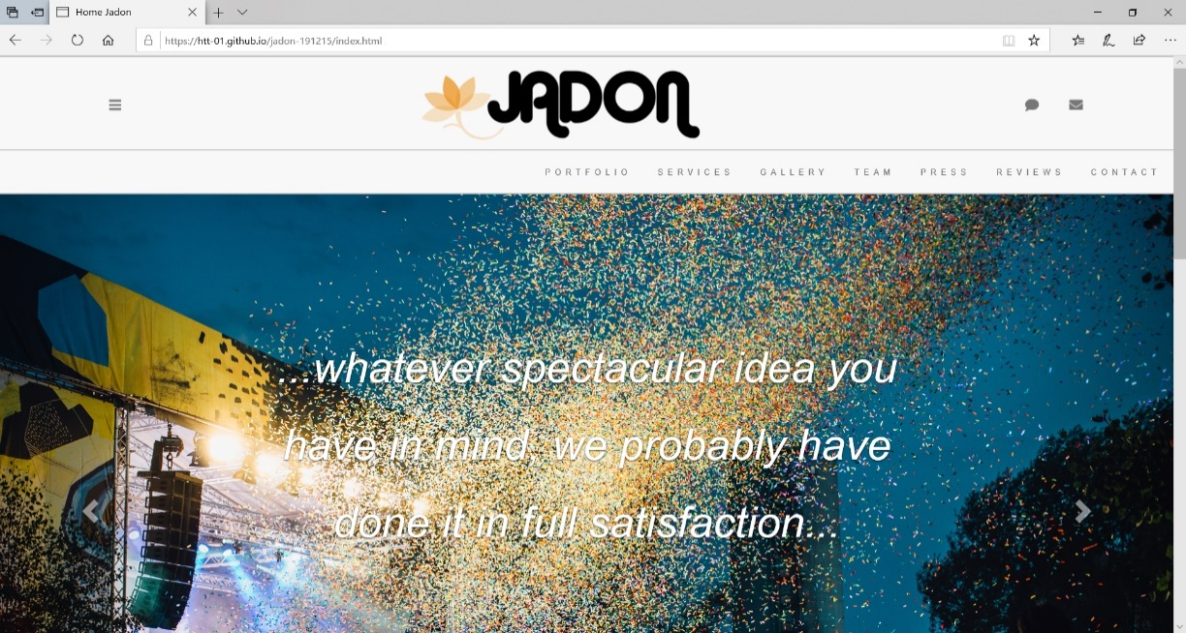

|  |  |  |
| --- | --- | --- |
| **Site Map Icon** |  | |
|  |  | Menu of Site Map  This menu contains links to all pages in this website. From here the user can get to any wehre within Jadon’s website. |
|  | | |
| **Top Website Navigation Menu** | This menu contain links to Main Pages of Jadon’s website | |
|  | | |
|  | | |
| **Jadon Logo** | Logo of Jadon is the link to go back to Home page | |
|  |  | |
|  | | |
| **Link to Message Form** | This icon is to pop up the **Feedback Form** for viewer to write to Jadon or for them to book an event | |
|  |  | |
|  | | |
| **Link to Email-to-Jadon** | This icon will start the email app on user computer, compose a new email with Jadon’s email as the receiver. | |
|  |  | |

### Footer

Footer is in the bottom of every page. It contains Link-to-Jadon-social-account Menu, Bottom Website Navigation Menu, Website Copyright Clause and Link to about-this-website.

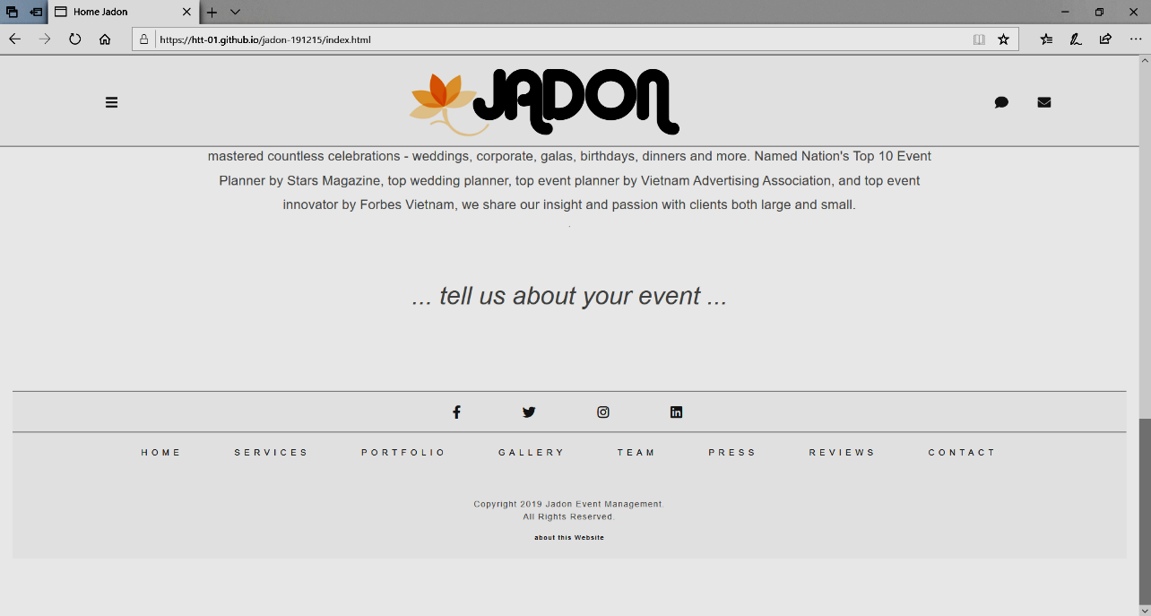

|  |  |
| --- | --- |
| **Link-to-Jadon-social-account Menu** | This menu contain links to Jadon’s account at facebook, twitter, pinterest and LinkedIn |
|  |  |
|  | |
| **Bottom Website Navigation Menu** | This menu contains 8 links to Main Pages of Jadon’s website |
|  | |
|  | |
| **Website Copyright Clause** |  |
|  |  |
|  | |
| **Link to about-this-website** | This text will link to the page containing message of the author of this website |
|  |  |

## Main pages

The website is divided into 8 main pages. They represent the functions of a normal website of business/company who provides services to customer:

### Home

This is the first page the viewer will see. It reflects Jadon’s first impression to viewer. This page contain introduction and abstract about Jadon. Detail content comprises of:

**Image slider**

|  |  |
| --- | --- |
|  | Slide 1:  Short message from Jadon to viewer |
|  | Slide 2:  Text “Portfolio” linked to Main page Portfolio |
|  | Slide 3:  Text “Services” linked to Main page Services |
|  | Slide 4:  Text “Gallery” linked to Main page Gallery |
|  | Slide 5:  Text “Team” linked to Main page Team |
|  | Slide 6:  Text “Team” linked to Main page Team |
|  | Slide 7:  Text “Contact” linked to Main page Contact |
|  | Slide 8:  Text “Write us” to open up Feddback form |

**Introduction about Jadon**

|  |  |
| --- | --- |
| Introduction paragraph |  |
|  | |

**Invite message to viewer**

|  |  |
| --- | --- |
|  | |
| **Link “tell us about your event”** | to open up Feddback form |

### Portfolio

This page is the capability statement of Jadon. This page presents to the user the experience in four main categories of Jadon’s business: corporate, private, school & non-profit, and wedding. Each of these categories contain 3 to 6 projects done by Jadon. The fifth category shows other types of event and the that Jadon’s capability is not limited to the above four categories. Detail content includes:

**Image slider**

|  |  |
| --- | --- |
|  | Slide 1:  Welcome slide, indicating that the page is to show Jadon’s works. |
|  | Slide 2:  Text “Corporate” linked to Corporate section of this page. |
|  | Slide 3:  Text “School & Non-profit” linked to School & Non-profit section of this page. |
|  | Slide 4:  Text “Private” linked to Private section of this page |
|  | Slide 5:  Text “Wedding” linked to Wedding section of this page |
|  | Slide 6:  Text “…how about…” linked to “…how about…” section of this page |

**Opening Statement for Portfolio**

|  |  |
| --- | --- |
| Opening paragraph for Portfolio |  |
|  | |

**Categories in Portfolio Main Page**

|  |  |
| --- | --- |
| Corporate | |
| Corporate section. 3 projects, each linked to pop-up slideshow of a project. | Pop-up slider    Bottom of the section is the link to section “Corporate” of the main page Gallery |
| School & Non-profit | |
| School & Non-profit section. 6 projects, each linked to pop-up slideshow of a project. | Pop-up silder    Bottom of the section is the link to section “school & non-profit” of the main page Gallery |
| Private | |
| Private section. 3 projects, each linked to pop-up slideshow of a project | Pop-up silder    Bottom of the section is the link to section “Private” of the main page Gallery |
| Wedding | |
| Wedding section. 3 projects, each linked to pop-up slideshow of a project | Pop-up silder    Bottom of the section is the link to section “Wedding” of the main page Gallery |
| Other types | |
| “..how about…” section. 2 projects, each linked to pop-up slideshow of a project | Pop-up silder    Bottom of the section is the link to section “Exhibition & Convention” of the main page Gallery |

### Services

This page describes all need-to-know about the service of the company. There are two points the user is interested in: scope of service and service tasks of events.

* Scope of services:

This determines the level of involvement by Jadon in managing the event. There are 3 formats for the scope of service which are detailed in 3 sub-pages of the main page “Services” with corresponding names:

* + Turn key premium service:
  + Limited service
  + A la carte
* Service tasks of event

There are four types of events of which the services can be standardized into detailed lists of tasks. They are organized in 4 sub-pages of the main page “Services” with corresponding names:

* + Service tasks of corporate
  + Service tasks of private
  + Service tasks of school & non-profit
  + Service tasks of wedding

The physical content of the main page “Service” includes:

**Opening Statement for Services**

|  |  |
| --- | --- |
| Picture with text “Services” linked to opening statement of “Services” Main page | |
|  | |
| Opening statement: Services Offerings | |
|  | |
| links to **Service tasks of event**  in Opening statement | |
| Link to **Service tasks of Corporate**  open up  Sub-page service-corporate |  |
| Link to **Service tasks of Private**  open up  Sub-page service-private |  |
| Link to **Service tasks of School & Non-profit**  open up  Sub-page service-School & Non-profit |  |
| Link to **Service tasks of Wedding**  open up  Sub-page service-wedding |  |

**Scope of services**

|  |  |
| --- | --- |
| Sypnosis for 3 scopes | |
|  | |
| Link to sub-page  Turn key premium service |  |
| Link to sub-page  Limited Edition service |  |
| Link to sub-page  A la carte service |  |

### Team

In this page Jadon wants to present to the viewer the core team that makes all these works possible.

**Opening statement for Team**

|  |
| --- |
| Picture with text “Team” above opening statement of “Team” Main page |
|  |
| Opening statement: |
|  |

**Team member introduction**

|  |
| --- |
| Picture of team members with introduction text |
|  |
|  |

### Gallery

This page is the image stock for the whole website. The images are categorized in five types of event corporate, private, school & non-profit, exhibition & convention. The page includes:

**Title text “Gallery” and navigation menu**

|  |  |
| --- | --- |
| Title text “Gallery” and navigation menu | |
|  | |
|  | |
| The navigation menu link | |
| link | Target section |
|  | Each image of the section is a link to a project  sliedshow |
|  | Each image of the section is a link to a project sliedshow |
|  | Each image of the section is a link to a project sliedshow |
|  | Each image of the section is a link to a project sliedshow |
|  | Each image of the section is a link to a project sliedshow |

### Press

This page contain links to all press article relating to Jadon. They were divided into 3 most recent year 2019, 2018 and 2017.

|  |
| --- |
| Title text “Press” |
|  |
| Articles in 2019 |
|  |
| Articles in 2018 and 2017 |
|  |

### Review

This page contains reviews of Jadon’s customers

|  |
| --- |
| Title text “Review” |
|  |
| Review section |
|  |
| Text “…tell us about your event…” linked to feddback form |
|  |

### Contact

This page contains information for viewer to contact Jadon. It includes phone number and email address of various departments,

|  |
| --- |
| Title text “Contact” and opening paragraph |
|  |
|  |
| Jadon’s phone numbers, emails, address and Feedback fom |
|  |
| Location map |
|  |

## Sub pages

### Turn key premium service

This page is the sub-page of main page “Services”. It contains:

|  |
| --- |
| Background picture with Title text “Turn key Planning Services” which is linked to specification of “turn key premium service” |
|  |
| Specification of “turn key premium service” |
|  |
| Text “…tell us about your event…” linked to feddback form |
|  |

### Limited service

This page is the sub-page of main page “Services”. It contains:

|  |
| --- |
| Background picture with Title text “Limited Edition Planning Services” which is linked to specification of “Limited Edition Planning Services” |
|  |
| Specification of “Limited Edition Planning Services” |
|  |
| Text “…tell us about your event…” linked to feddback form |
|  |

### A la carte

This page is the sub-page of main page “Services”. It contains:

|  |
| --- |
| Background picture with Title text “À la carte” which is linked to specification of “À la carte” |
|  |
| Specification of “À la carte” |
|  |
| Text “…tell us about your event…” linked to feddback form |
|  |

### Service tasks of corporate

This page is the sub-page of main page “Services”. It contains:

|  |
| --- |
| Background picture with Title text “Corporate Events” which is linked to opening statement about Jadon’s corportate event service |
|  |
| opening statement about Jadon’s corportate event service |
|  |
| List of tasks for corporate event |
| Text “…our corporate portfolio…” linked to “corporate” section in main page “Gallery” |
|  |
| Text “…OR tell us about your event…” linked to Feedback form |
|  |

### Service tasks of private

This page is the sub-page of main page “Services”. It contains:

|  |
| --- |
| Background picture with Title text “Private Events” which is linked to opening statement about Jadon’s private event service |
|  |
| opening statement about Jadon’s private event service |
|  |
| List of tasks for private event |
|  |
| Text “…our private portfolio…” linked to “private” section in main page “Gallery” |
|  |
| Text “…OR tell us about your event…” linked to Feedback form |
|  |

### Service tasks of school & non-profit

This page is the sub-page of main page “Services”. It contains:

|  |
| --- |
| Background picture with Title text “School & Non-profit Events” which is linked to opening statement about Jadon’s School & Non-profit Events service |
|  |
| opening statement about Jadon’s School & Non-profit Events service |
|  |
| List of tasks for School & Non-profit Events |
|  |
| Text “…our school & non-profit portfolio…” linked to “school & non-profit” section in main page “Gallery” |
|  |
| Text “…OR tell us about your event…” linked to Feedback form |
|  |

### Service tasks of wedding

This page is the sub-page of main page “Services”. It contains:

|  |
| --- |
| Background picture with Title text “Wedding Events” which is linked to opening statement about Jadon’s Wedding Events service |
|  |
| opening statement about Jadon’s Wedding Events service |
|  |
| List of tasks for Wedding Events |
|  |
| Text “…our wedding portfolio…” linked to “wedding” section in main page “Gallery” |
|  |
| Text “…OR tell us about your event…” linked to Feedback form |
|  |

### Under construction

This page is displayed in cases where the link is not ready at the current time

|  |
| --- |
| Under-construction message |
|  |

### About this website

This page will display when user clicks on the link “about this website”

This Page contains message from the authors of this website regarding copyright, fact-check, intention, purpose and usage of this website and its materials.

|  |
| --- |
| About this website |
|  |

# Developer’s Guide

This project is the very first step to build the website for Jadon. Completion of this step has fixed the branding design for Jadon. There is no database nor module system required at this stage hence there is no need for a comprehensive developer’s guide.

In the next steps, depending on decision on the forward direction, Developer team will advise Jadon to develop the following systems which are integrated with this website and it will require a serious development guide and strategy:

* Vendor & supplier & inventory management system
* Customer management system
* online-marketing management system

# Appendices

## Appendix 9-1: Task Sheet

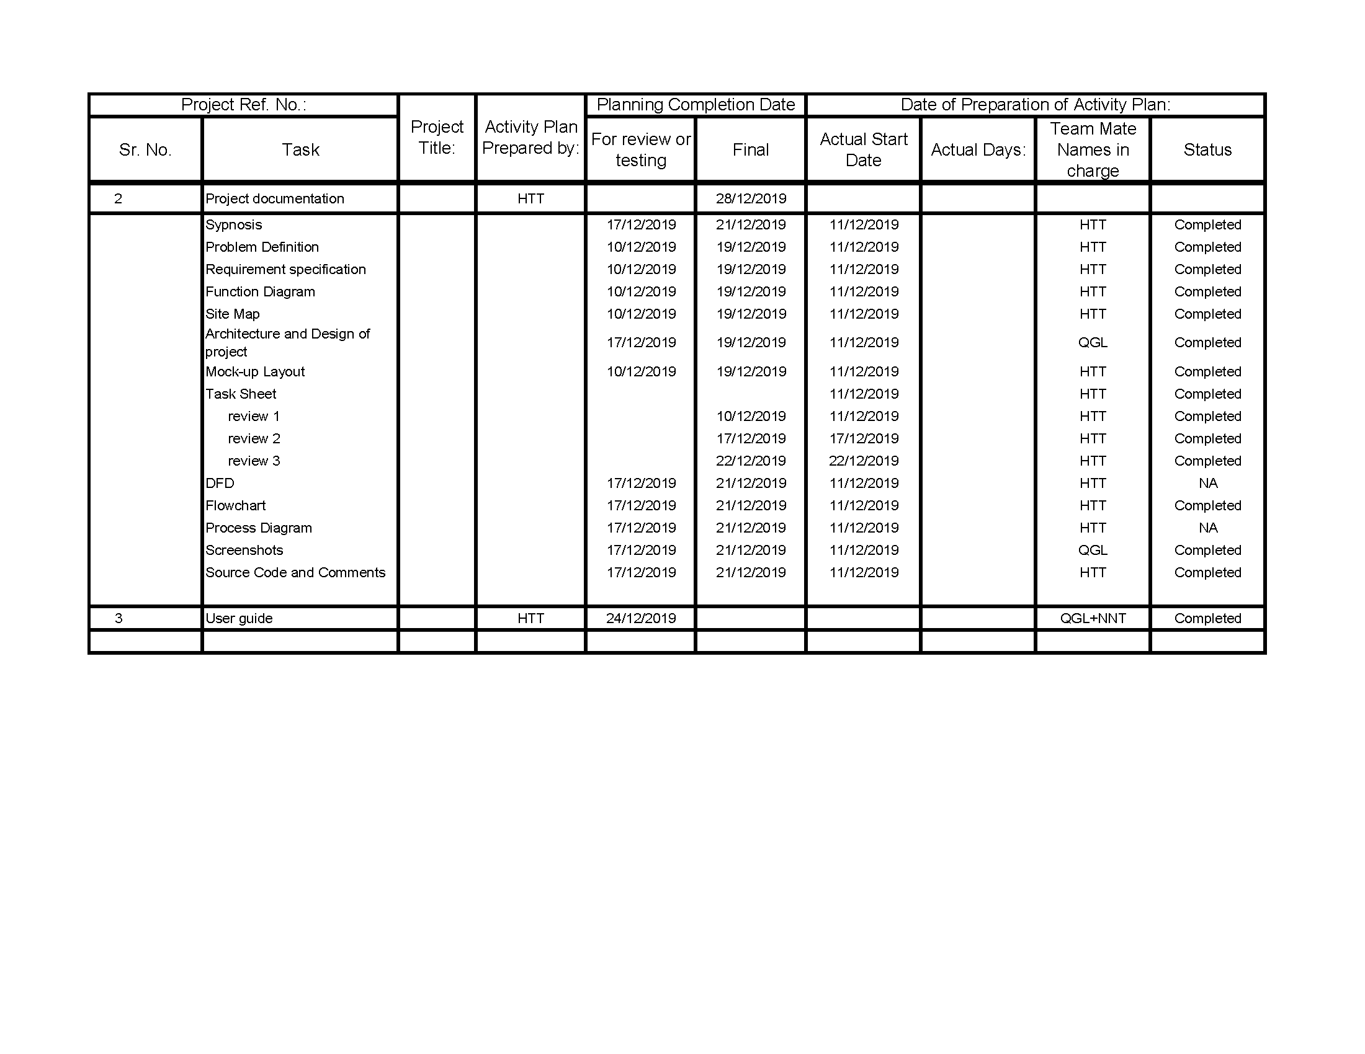

## Appendix 9-2: Mock-up of Website layout

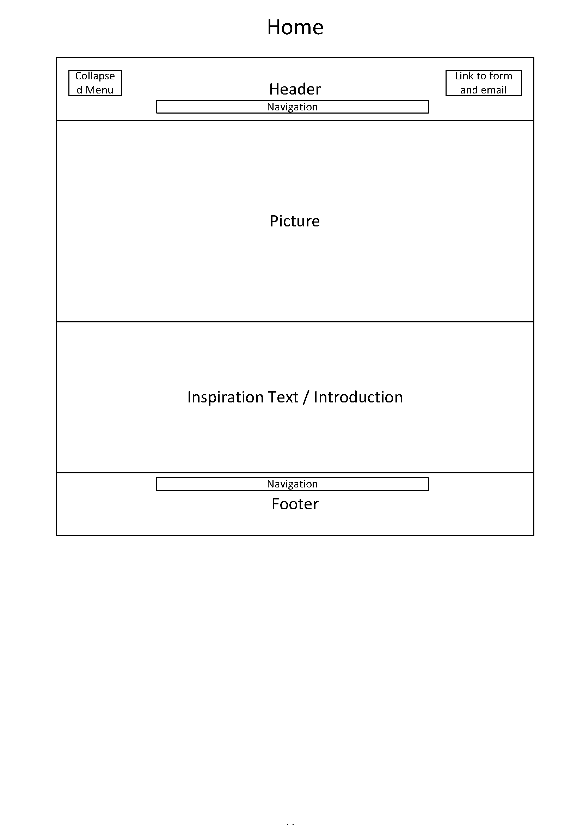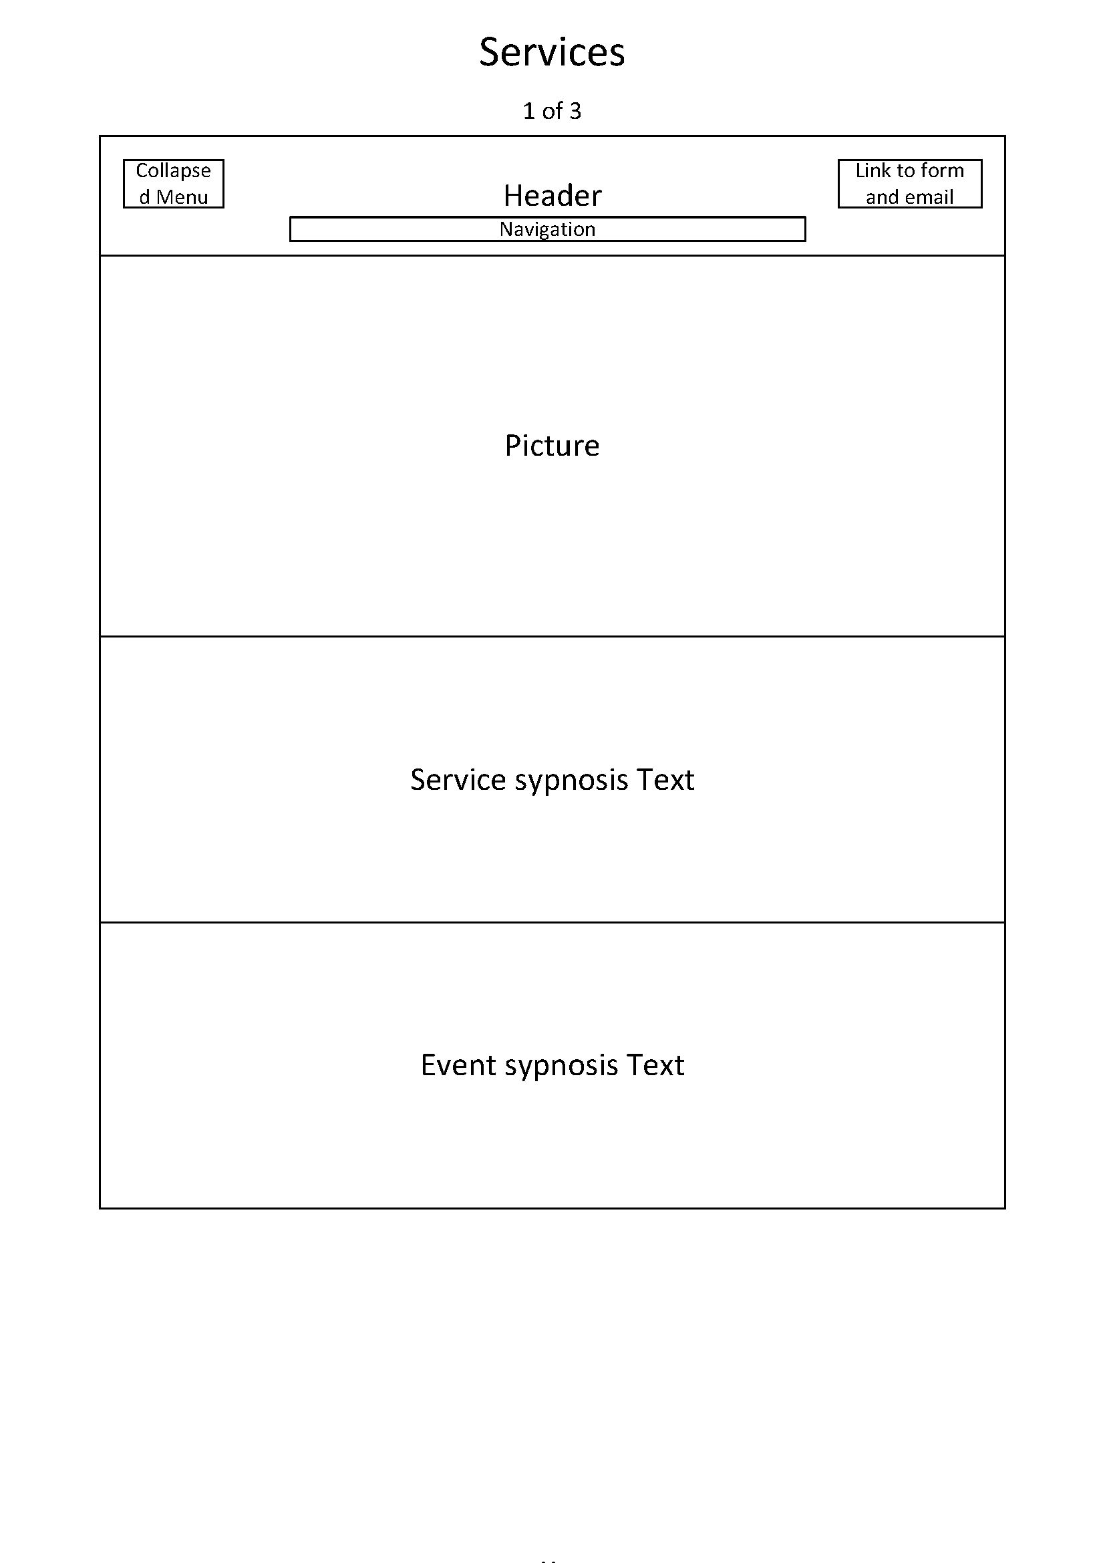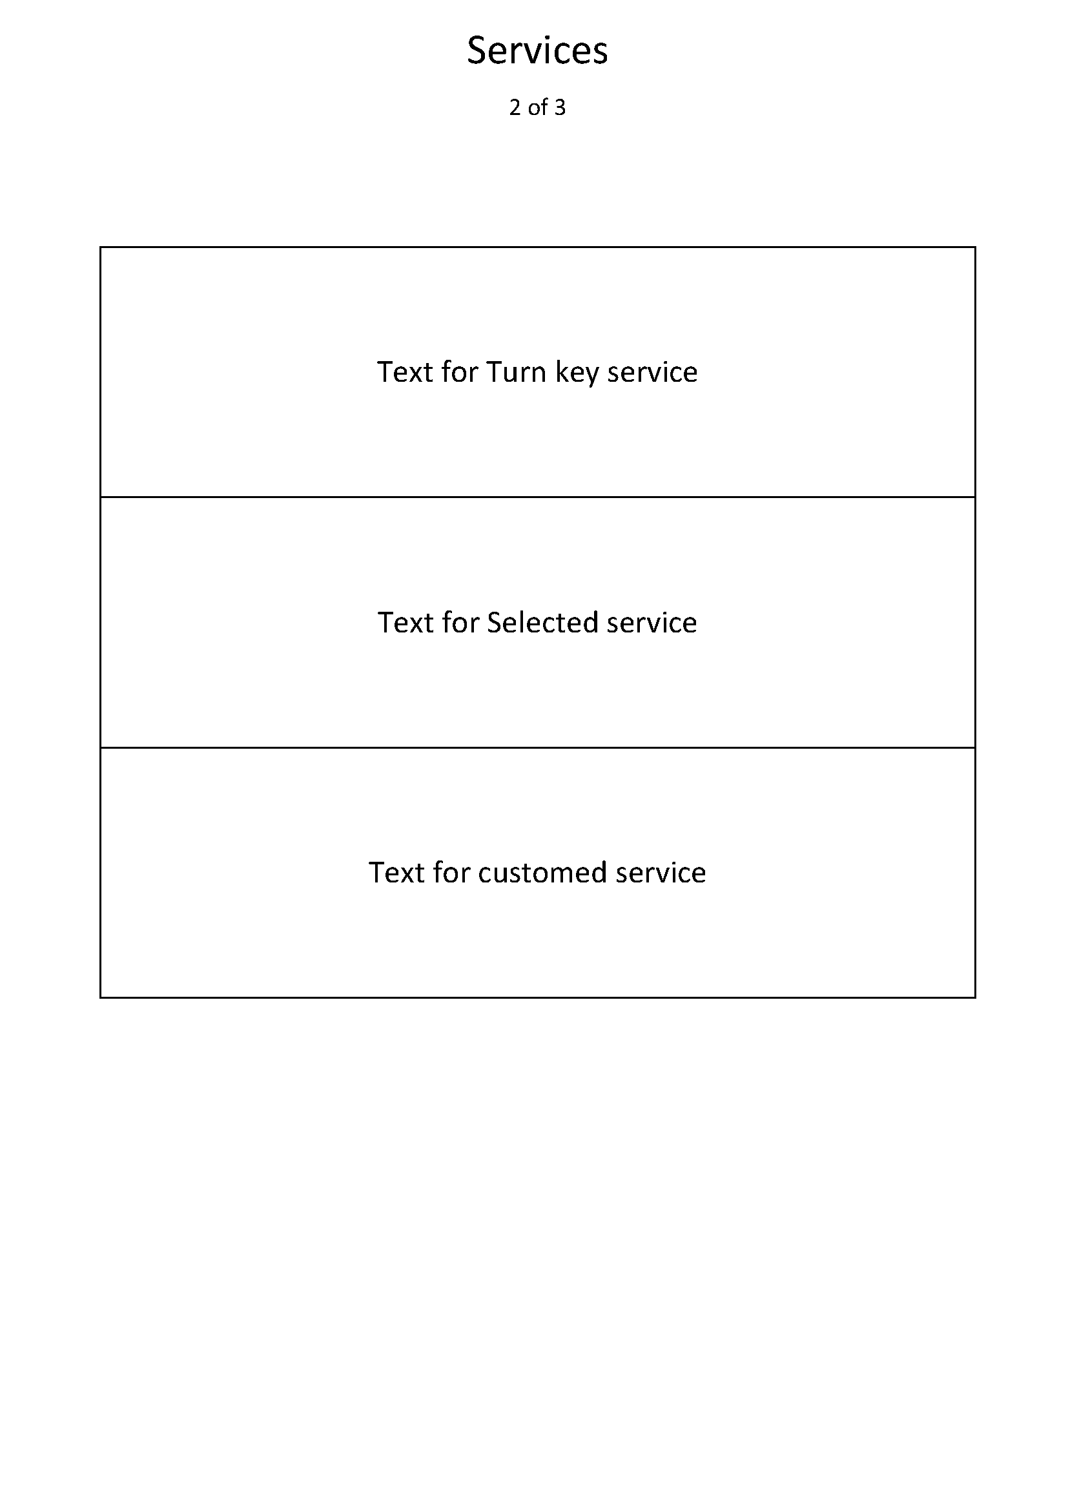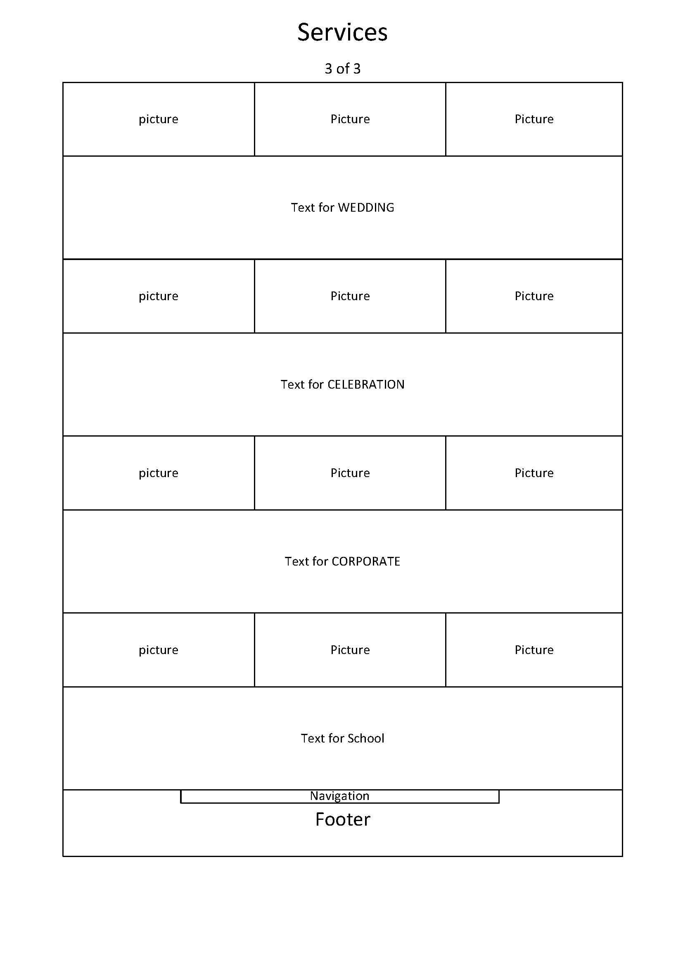

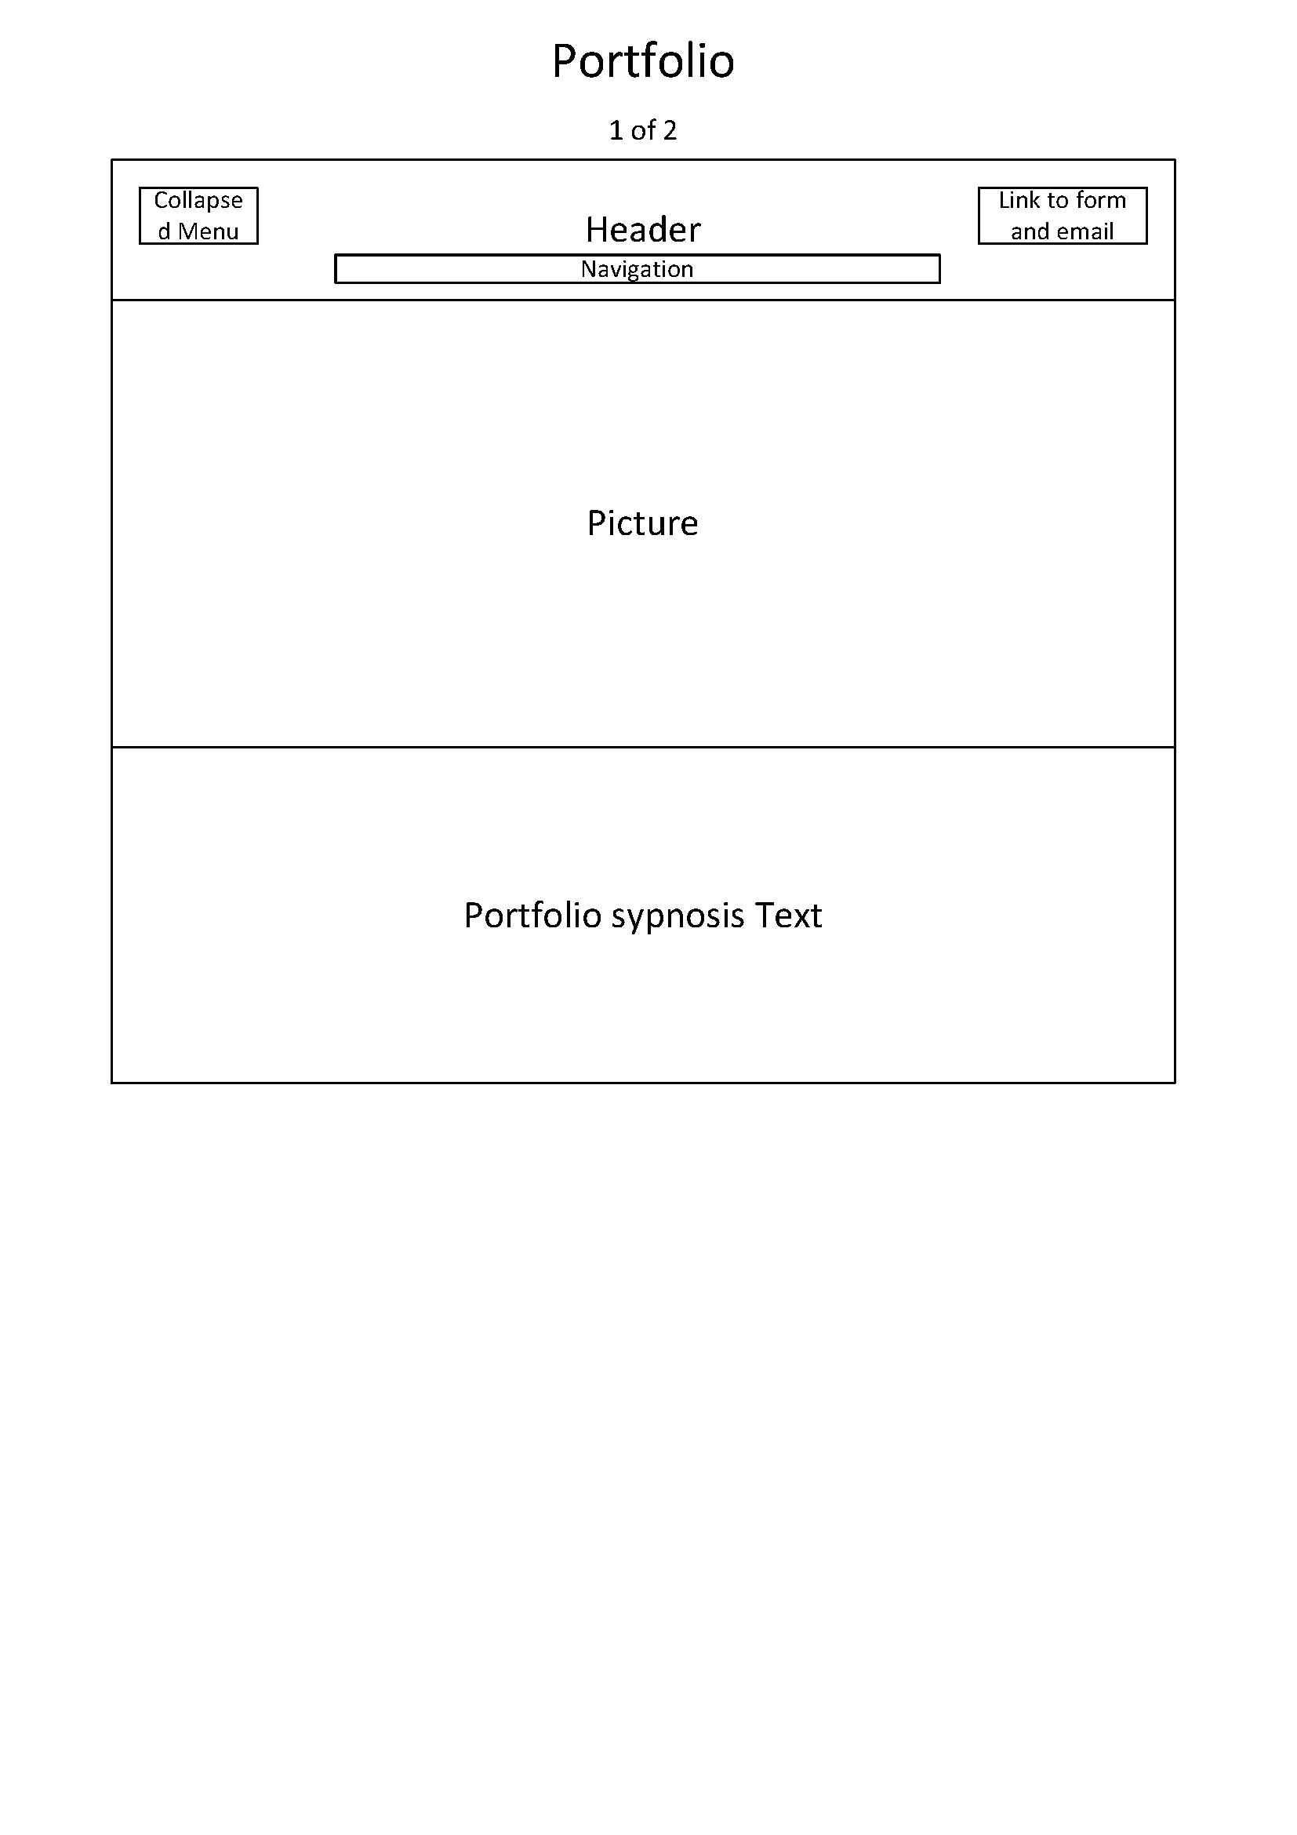

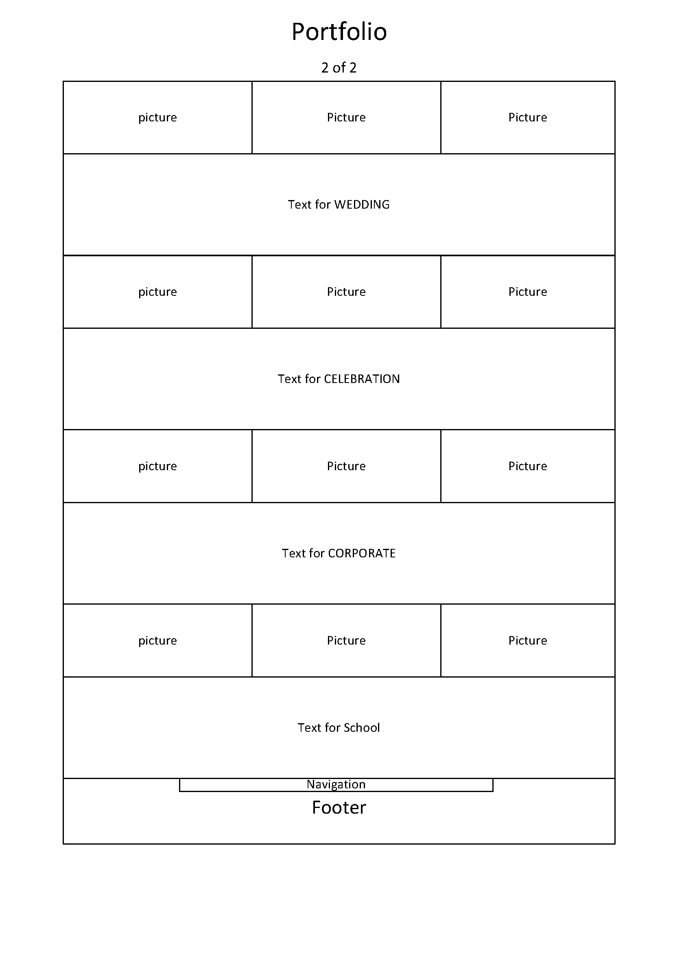

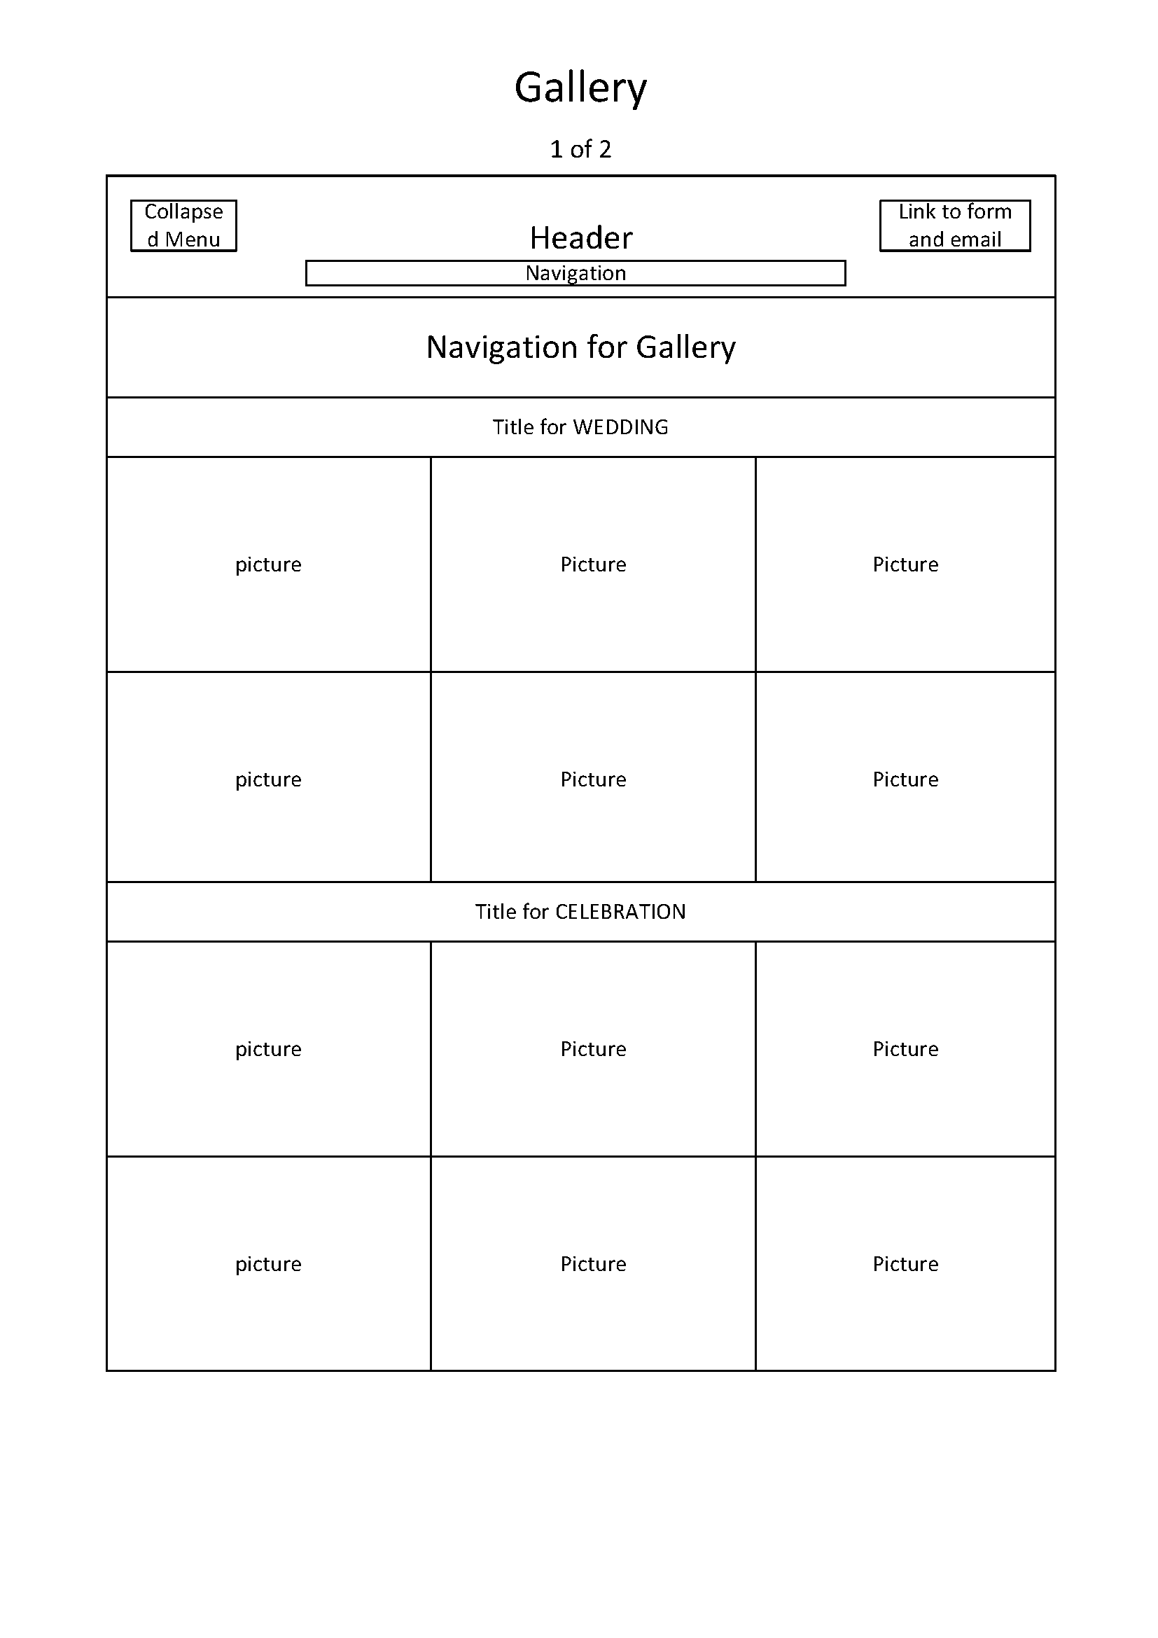

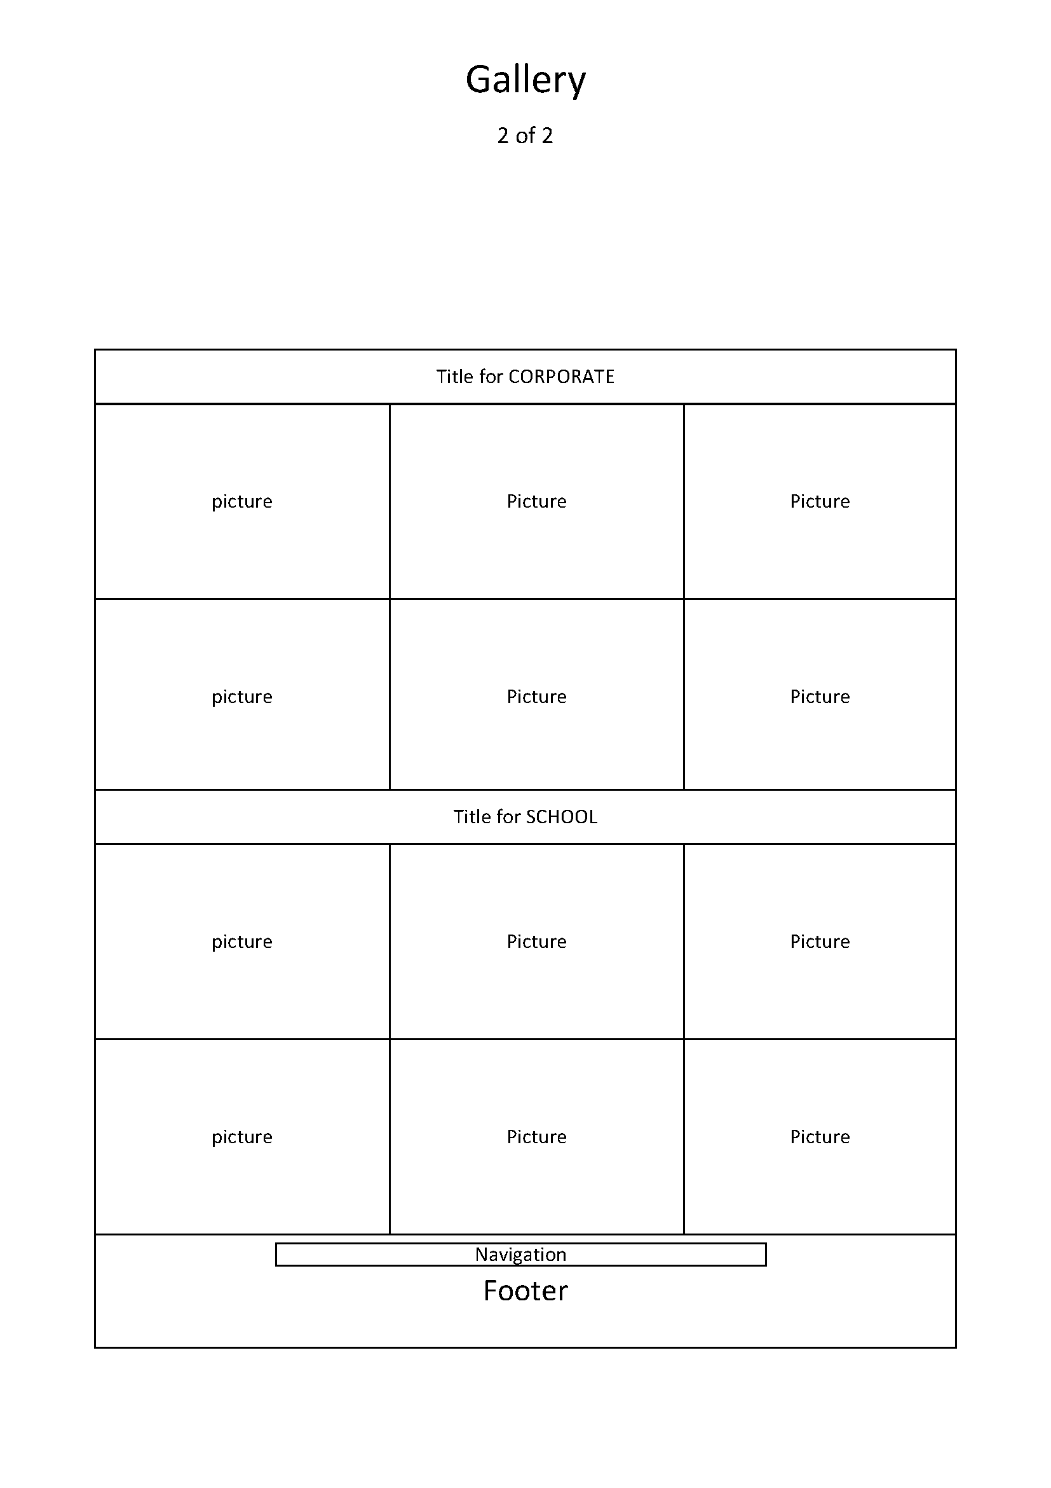

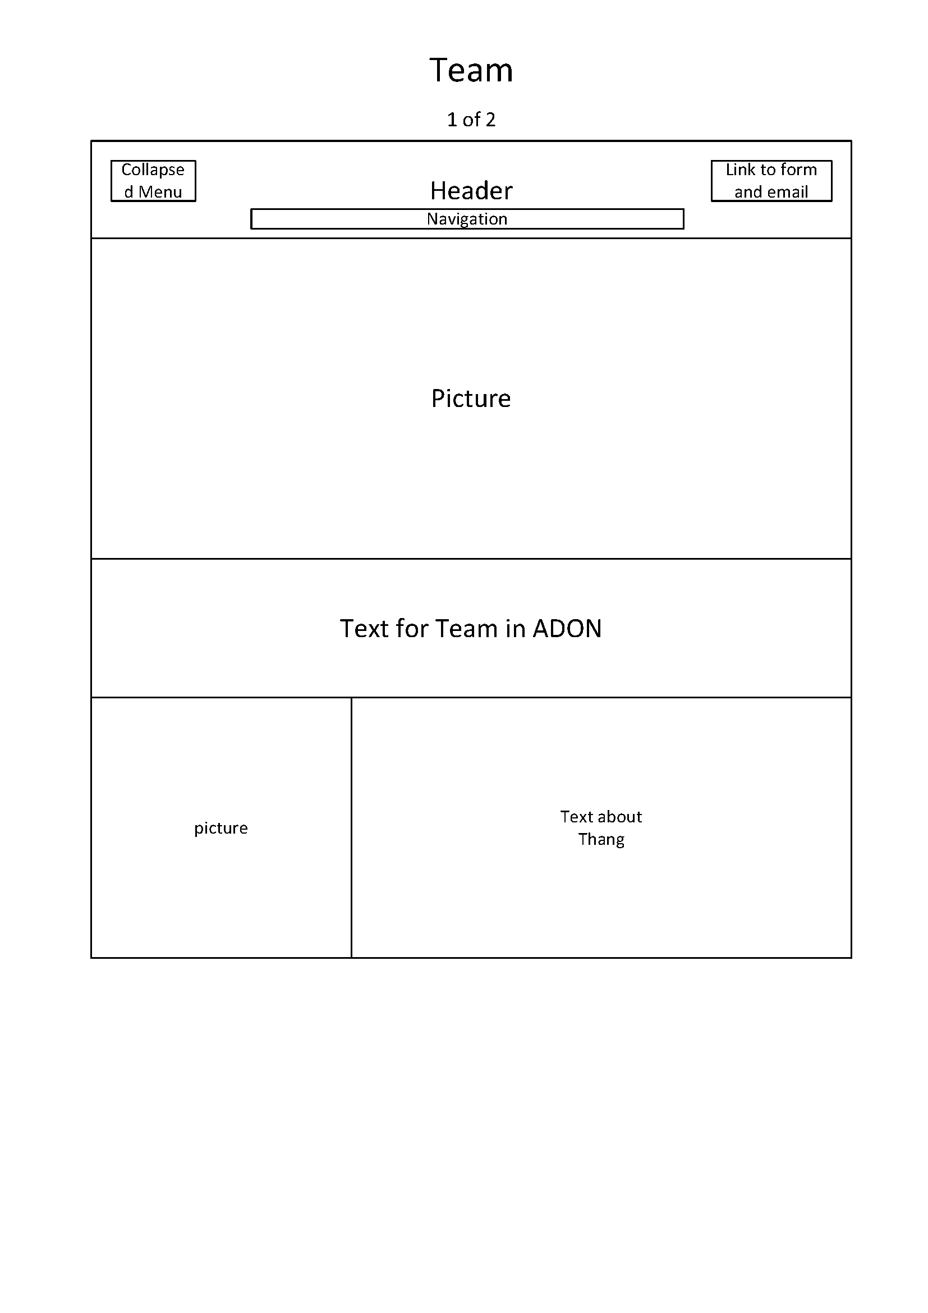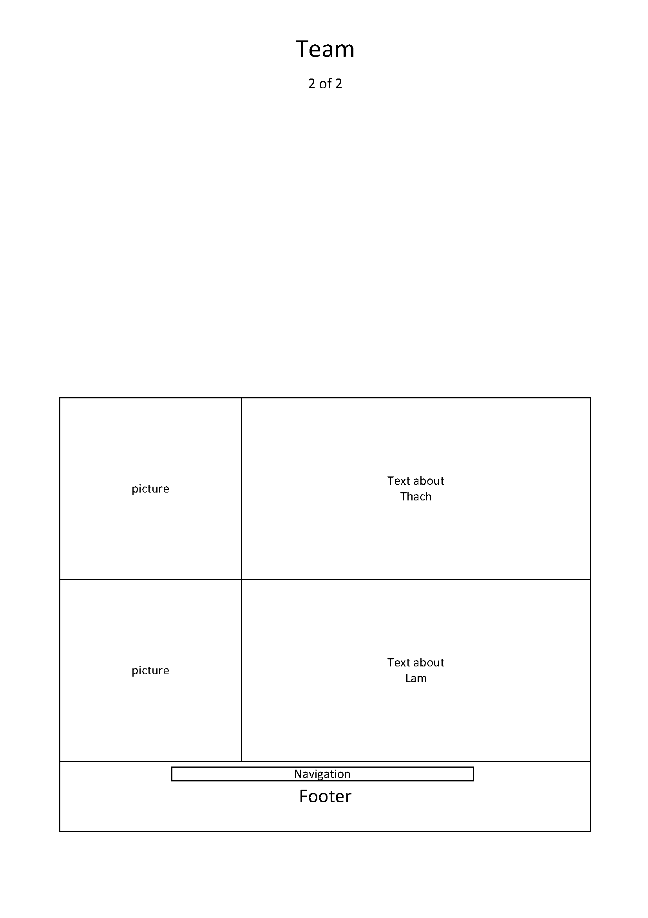

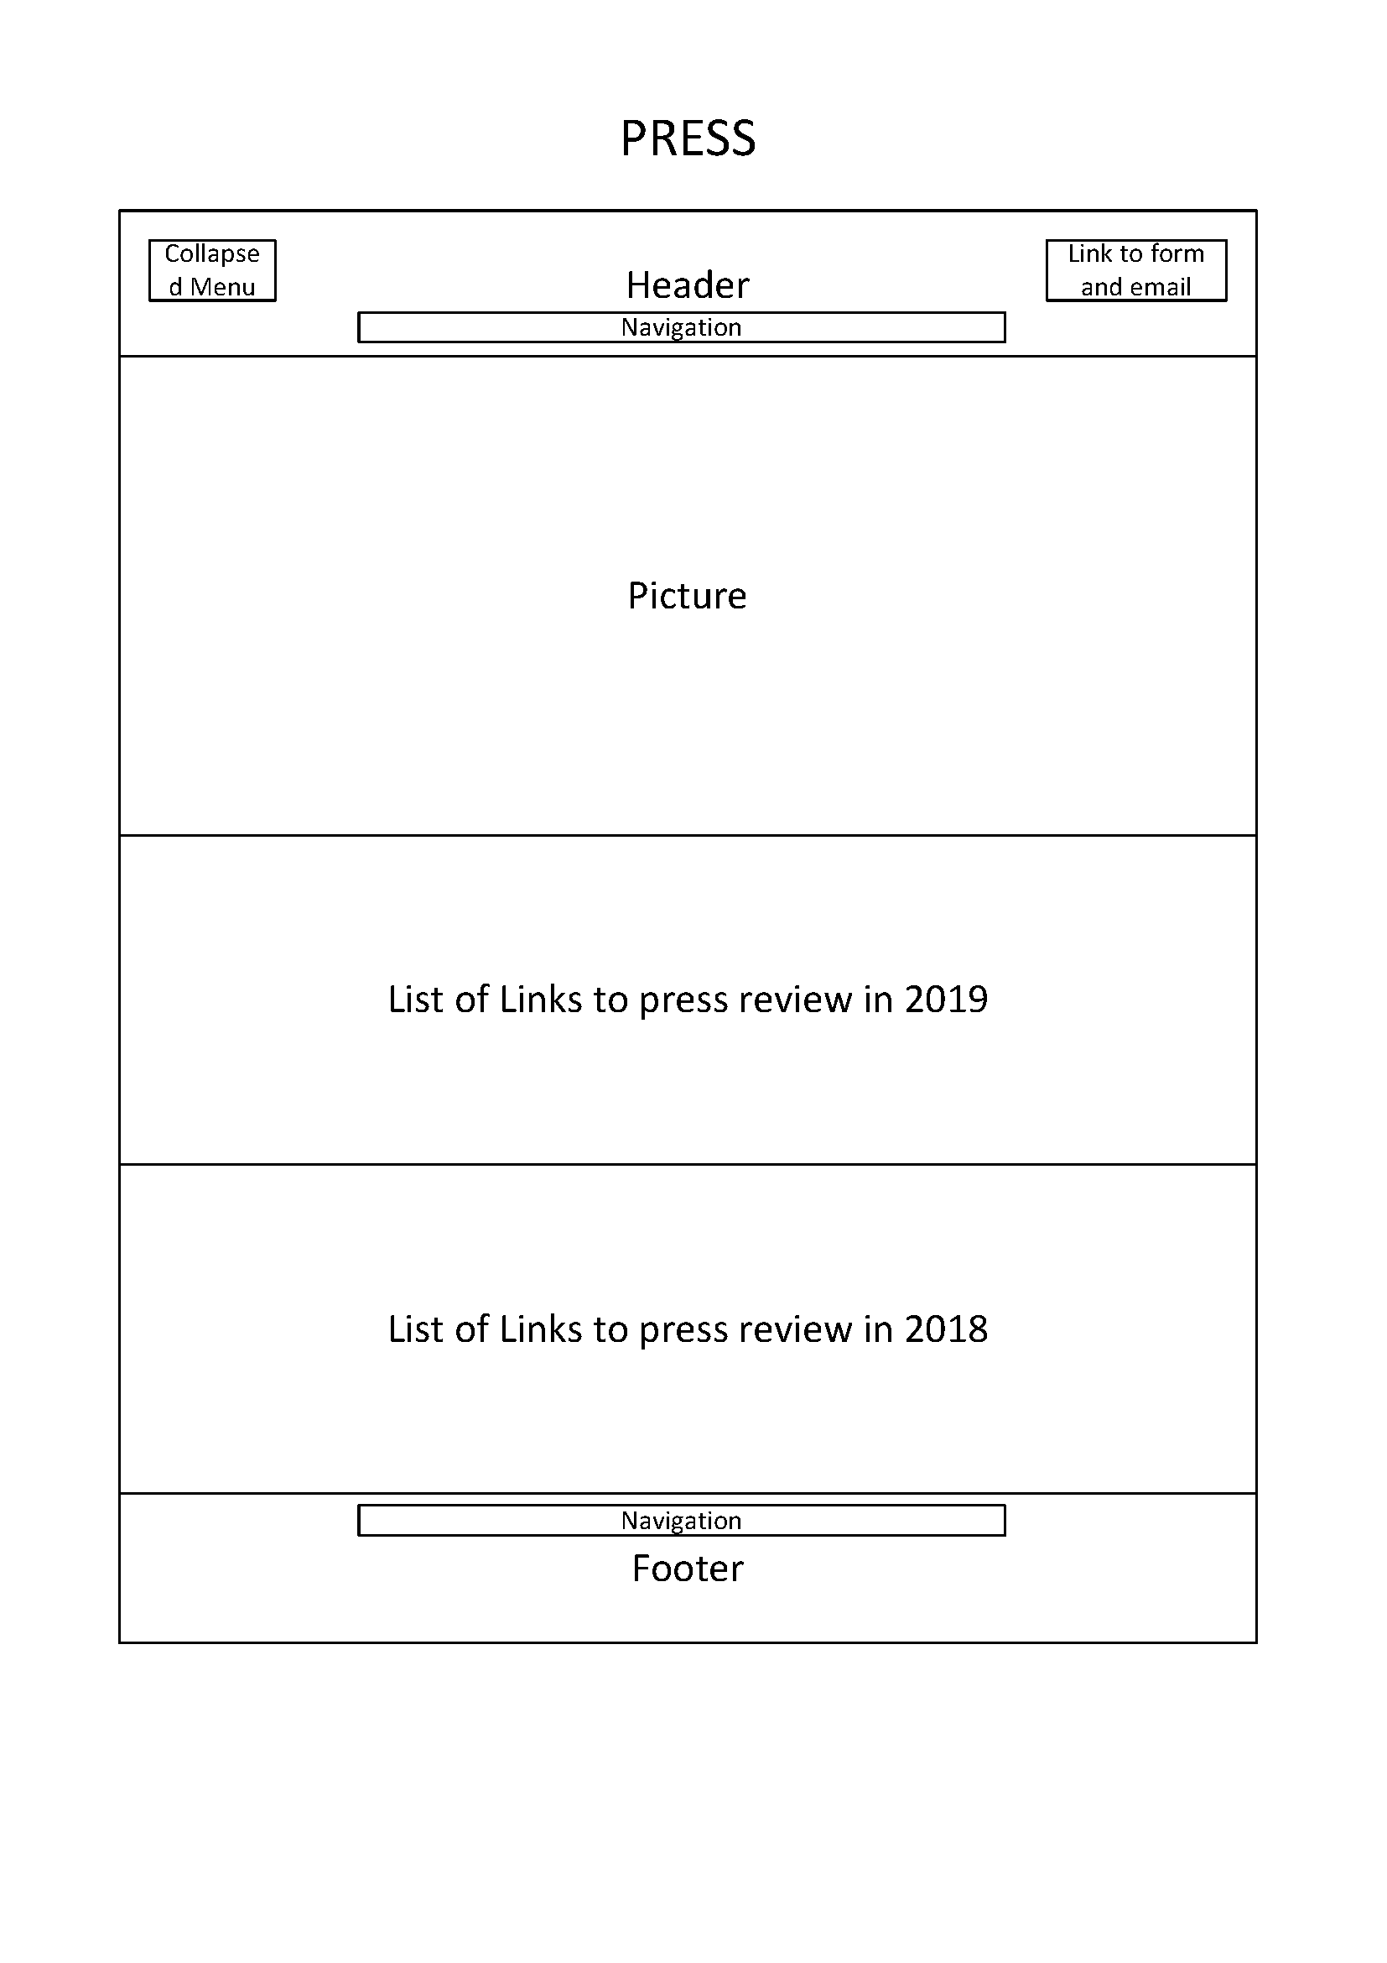

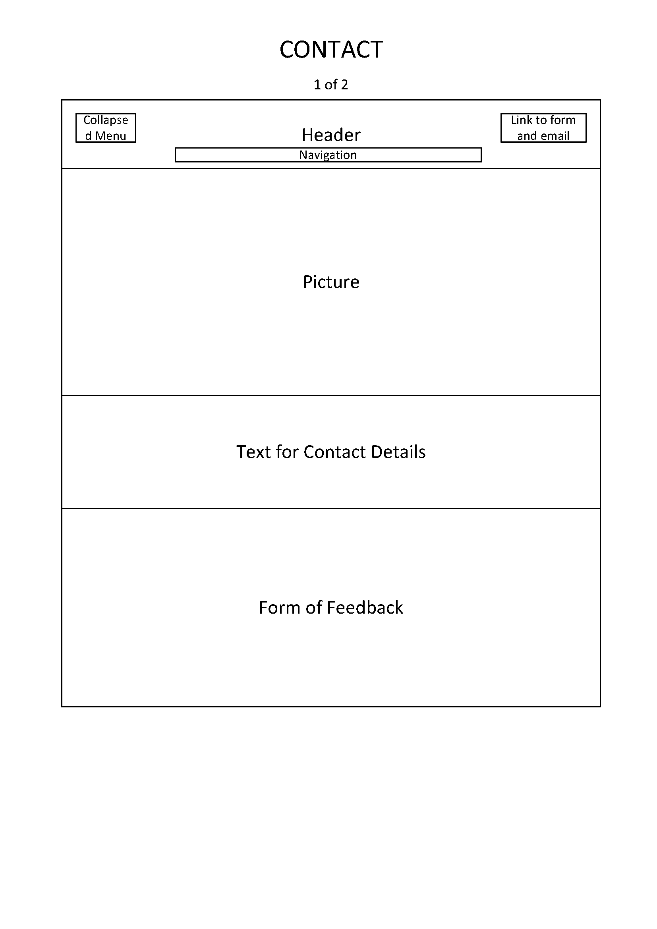

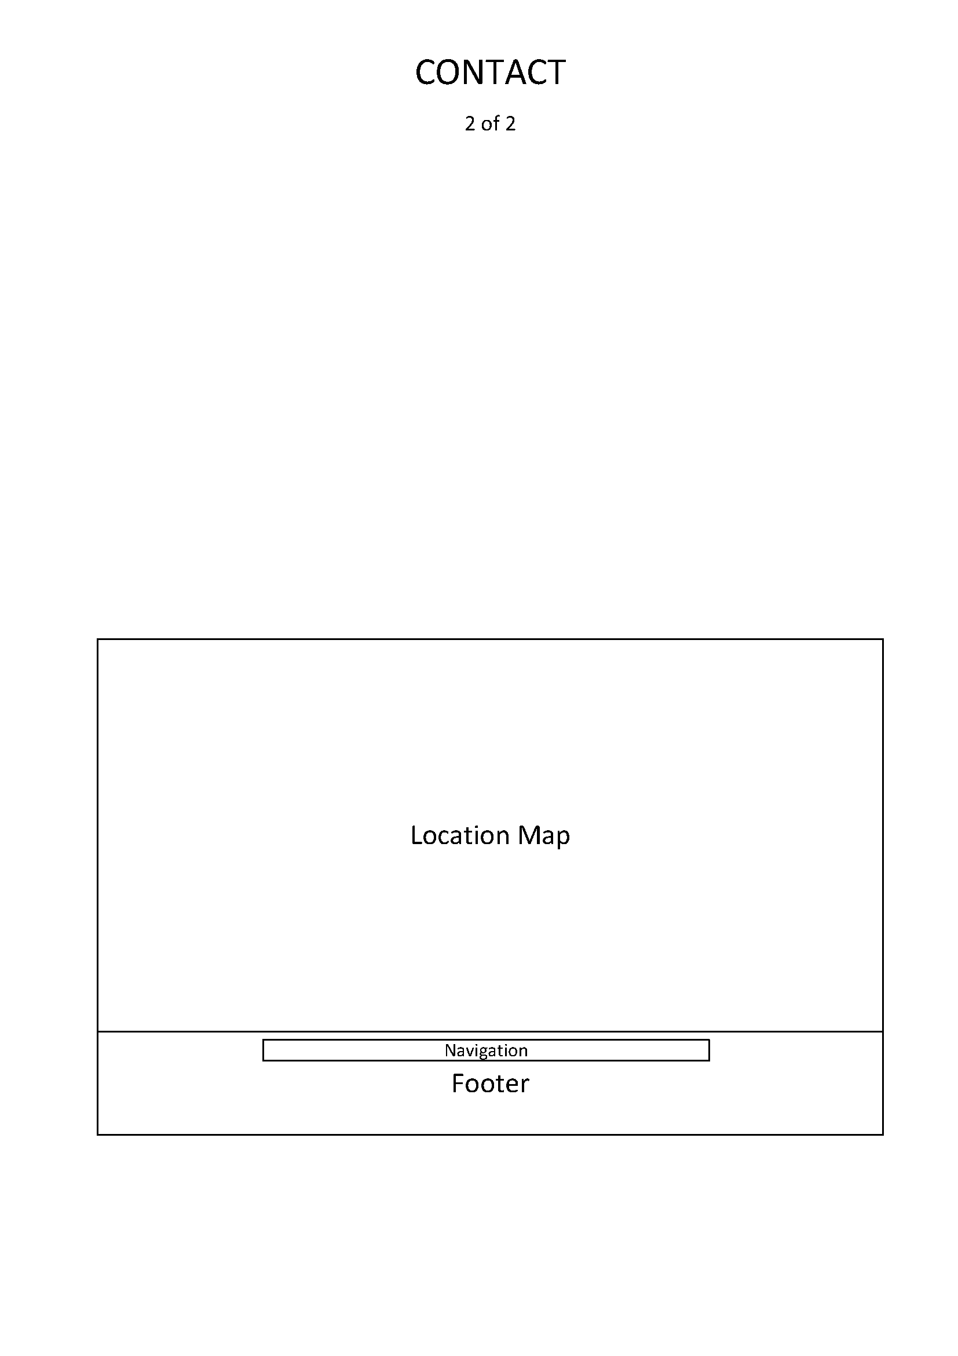

# The End